For assignments you complete on paper please convert your work to PDF.
You can use the following app to convert your work to PDF

https://www.youtube.com/watch?v=vPhPYquViQ8

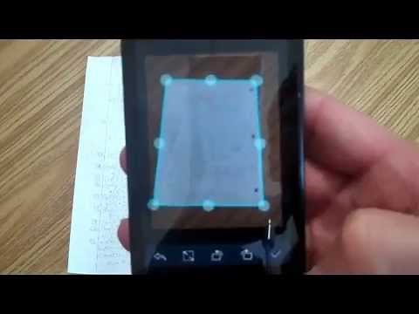 | Using CamScanner to email homework as PDF file  Tutorial showing how to use the CamScanner APP to send homework papers to an email as an attached PDF file.  www.youtube.com

