CLAS Simulations for the E5 Data Set

Robert Burrell
(G.P.Gilfoyle, K.Gill)

April 16, 2007

1 Introduction

The Thomas Jefferson National Accelerator Facility (Jefferson Lab) located in Newport News, Virginia, is used to study the quark-gluon structure of protons, neutrons, and atomic nuclei. Jefferson Lab is home to a large electron accelerator, the Continuous Electron Beam Accelerator Facility (CEBAF) which is the central instrument. Jefferson Lab is also home to the CEBAF Large Acceptance Spectrometer (CLAS) detector, which measures scattered particles from high-energy collisions of an electron beam and a nuclear target. The CLAS detector is large (10 meters in diameter, 45 tons), and misalignments may occur among the thousands of components within the detector. These imperfections jeopardize the accuracy and precision of our final analysis. In this project we attempt to identify these effects using a simulation of CLAS so that we may correct for them in our analysis.

Research was done with fellow undergraduate Kuri Gill in the summer of 2006 under the supervision of Dr. Gerard Gilfoyle.

2 Background and Significance

2.1 Standard Model and Quantum Chromodynamics
Since the beginning of time, man has wondered, "What is the world made of?" We have come to realize that the world's matter is made from a few fundamental building blocks. The question then becomes, "What is fundamental?" We use the term fundamental to mean simple and structureless – not made of anything smaller.
Around 1900, people thought that these fundamental building blocks were atoms; the word atom from the Greek term "atomos" literally means "that which cannot be divided." Through later experimentation scientists discovered a nucleus consisting of protons and neutrons, surrounded by a "cloud" of orbiting electrons.
We have since discovered that protons and neutrons can be broken down into even smaller constituents: particles known as quarks. Quarks are thought to be point-like particles, not made up of anything smaller.
Scientists are constantly looking for and discovering new particles. In order to categorize and describe these fundamental particles and their interactions, scientists have come up with the Standard Model (see Figure 1). This model outlines how matter is comprised of two types of particles: fermions, which include six flavors of quarks and six different leptons (such as the electron); and bosons, which are force carriers such as the photon and the gluon.
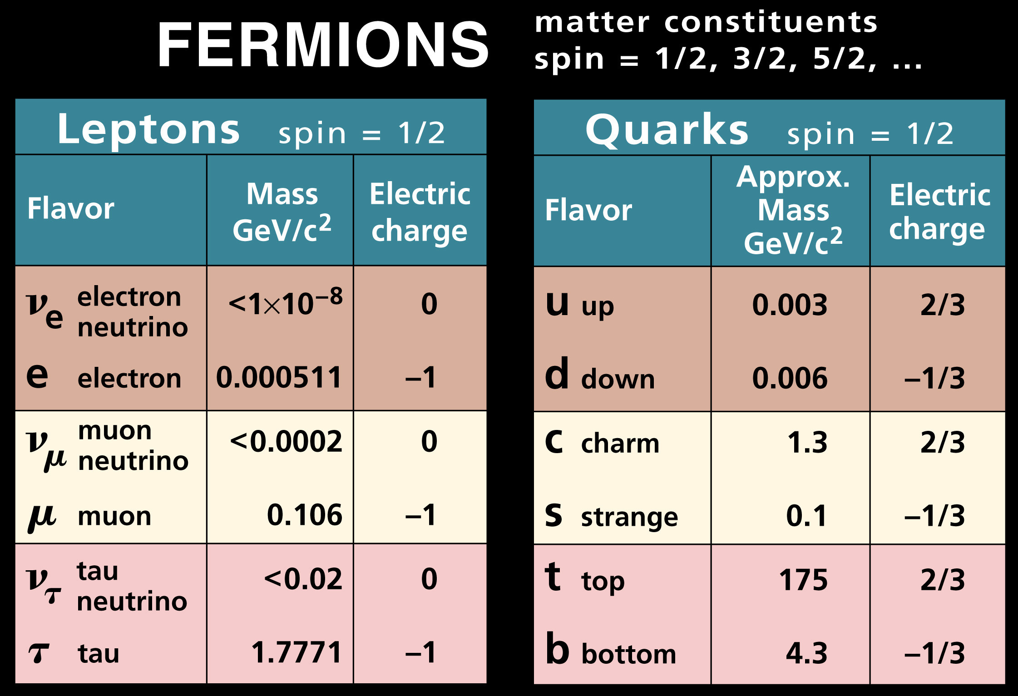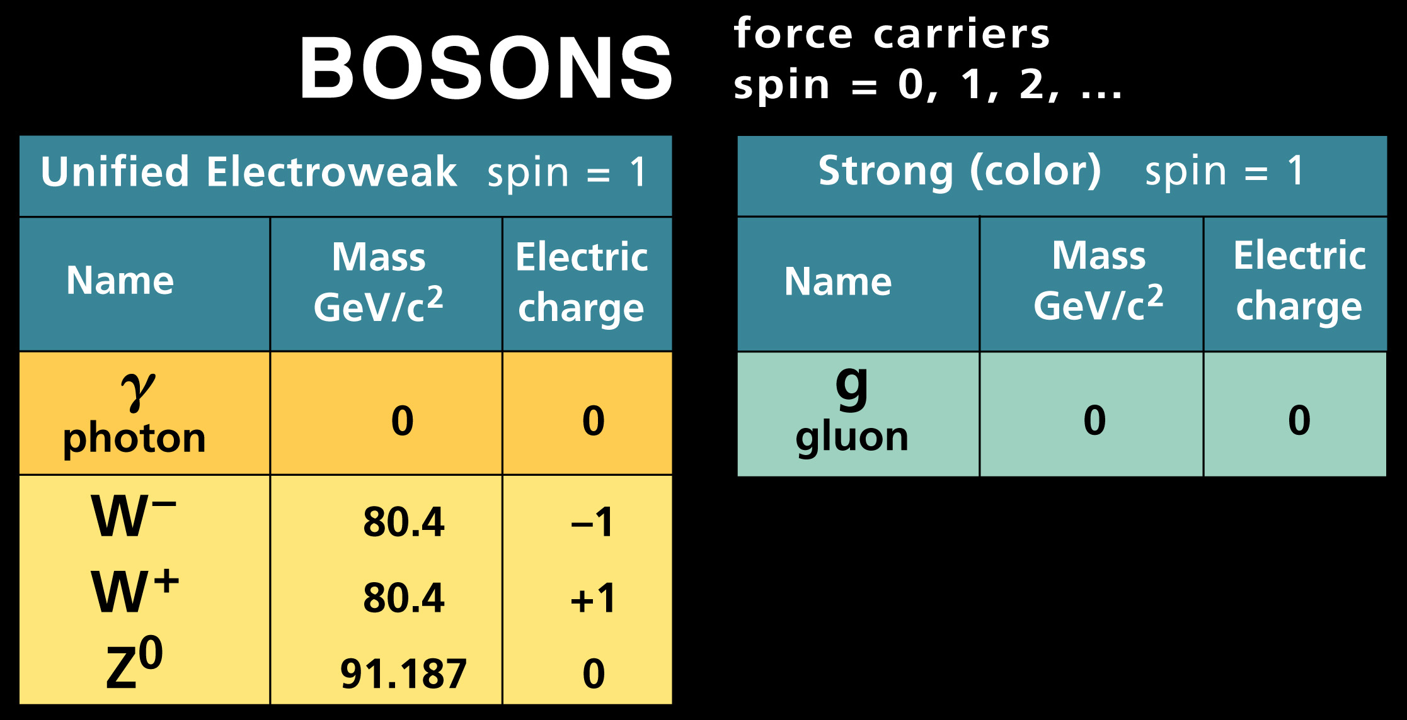[1]
Figure 1. The Standard Model. Fermions consist of six flavors of quarks alongside six types of leptons, such as the electron (left). Bosons, or force carriers, are comprised of electroweak, strong, and gravitational forces. The graviton is not displayed as it has not yet been observed.
Bosons, or force carriers, can be separated into three categories of forces: the electroweak, strong, and gravitational forces. The elecroweak forces are the familiar electromagnetic forces between electrically charged particles along with the less-familiar weak force responsible for certain radioactive decays. The strong or color force, whose force carrier is the gluon, is the fundamental force describing the interactions of quarks and gluons. Gluons bind quarks together in pairs or groups of three to make hadrons (protons, neutrons, pions, etc.). The theory describing the color force is known as quantum chromodynamics (QCD). The gravitational force, although clearly one of the fundamental forces, is not satisfactorily explained now. Its force carrier particle, the graviton, has not yet been discovered. Fortunately, the effects of gravity are extremely small compared to the other forces in play.
The theory of quantum chromodynamics entertains two strange properties: asymptotic freedom and confinement. Normally quarks and gluons have a very strong force between them; asymptotic freedom is the observation that in very high-energy reactions, quarks and gluons interact very weakly. Confinement, on the other hand, refers to the observation that the (strong) force between quarks and gluons does not diminish as they are separated. This is contrary to the other forces like the electromagnetic force and gravity. A typical plot of the potential between quarks and gluons as a function of distance of separation is given in Figure 2. A derivative of this plot would reveal a constant force of around 22 tons between the particles.

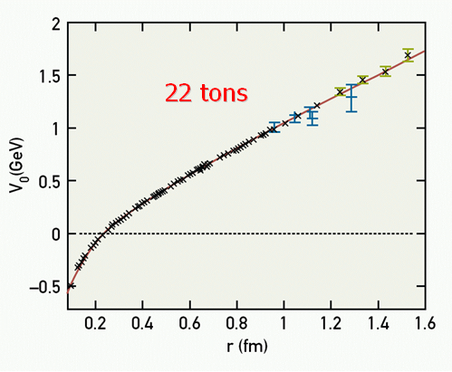
“Opportunities in Nuclear Science: A Long Range Plan for the Next Decade,” DOE/NSF Nuclear Science Advisory Committee (April 2002)
Figure 2. Confinement. The potential between two quarks rises linearly as a function of separation. The force between two quarks is constant ~22 tons, at any separation distance r. This means the quarks not to be separated.
QCD and the Standard Model have been very successful at high energies. Unfortunately, at the energies of atomic nuclei, we have been unable to describe nature from a quark-gluon perspective. We lack both the theoretical tools to perform the calculations and there is little data to challenge theory. Filling in the gap in our understanding is the mission of Jefferson Lab.
2.2 Jefferson Laboratory
It is the objective of Jefferson Lab to understand the atomic nucleus at the quark level. We look to understand more about the nature of quarks and their interaction with gluons, as well as other sub-atomic particles and their respective interactions.
Although Jefferson Lab isn't one of the largest or highest-energy accelerator facilities, it is one of the newest laboratories with some of the highest-quality beam and most sophisticated detectors in the world. It was born out of a 1979 Nuclear Science Advisory Committee which cited “the need for a new accelerator with detectors able to study matter on the scale of nucleon-quark transition.” [3]
The accelerator itself lies 25 feet underground in a racetrack-shaped tunnel 7/8 mile around (see Figure 3). The accelerator is currently capable of producing electron beams from 2-6 GeV, although plans have been devised to upgrade the facility to 12 GeV capabilities. The beam is accelerated along the straight sections in what are called LINACs (short for linear accelerators), and it is bent around the turns using a series of magnets. Through this process, the beam is able to travel around the accelerator track up to five times at a speed near the speed of light. The beam is then sent to one of three halls (Halls A, B, and C) where it collides with a target and resulting particles are scattered into the detector.
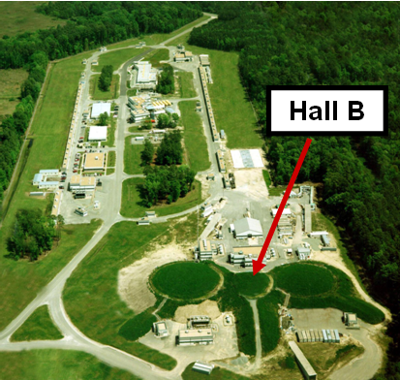[3]
Figure 3. Jefferson Lab. Electron beams can travel around the race-track shaped accelerator up to five times at the speed of light before being distributed to one of three detector halls; CLAS is located in Hall B.
2.3 CEBAF Large Acceptance Spectrometer

My research at the University of Richmond’s Physics Department is based on study of the CEBAF Large Acceptance Spectrometer (CLAS) detector in Hall B at Jefferson Lab. Measurements taken within CLAS and the resulting analyses often have uncertainties stemming from imperfections within the detector. To investigate these uncertainties, we simulate the performance of CLAS.

CLAS, which is located in Hall B at Jefferson Lab, is used to detect electrons, protons, pions and other subatomic particles. CLAS is a nearly 4π detector, meaning that it is able to detect almost all of the debris from a nuclear collision. It is a large (10-m diameter, 45-ton) spectrometer, designed to measure and identify the debris from a nuclear collision. A toroidal magnetic field bends the trajectories of charged particles through CLAS and enables us to measure their momenta and velocities, which leads to a calculation of mass that is used to identify the particle.

The particles go through each region of CLAS leaving behind electronic information that is collected and stored on tape. The event rate is high (about 4500 Hz), so the initial data analysis is done at JLab, and we analyze more deeply those results at the University of Richmond. There are six different layers of CLAS (see Figure 4) that produce electrical signals that provide information on velocity, mass, and energy of the nuclear debris, and allow us to identify and separate different subatomic particles.

[4]
Figure 4. CEBAF Large Acceptance Spectrometer

The first three regions of CLAS are the drift chambers, where charged particles are tracked. They consist of a large volume of gas with thin wires at high positive voltage embedded in the gas. A high-energy charged particle passing through the gas knocks electrons off the gas atoms. These electrons are collected at the wires to produce an electronic pulse which marks the location of the passage of the original charged particle. This information is collected from many wires and the particle’s path is reconstructed. The first region, closest to the target, is used to determine the initial direction of the particle; the second region is within the toroidal magnetic field. The magnetic fiend bends the particles trajectory. The third region is in a region with no magnetic field and is used to make a final measurement of the path of the charged particle.

The next region within CLAS is the Cerenkov counters in which the Cerenkov effect is used to make an important distinction between electrons and positive pions. High-energy charged particles (mostly electrons) pass through the medium at a speed greater than the speed of light and give off light. It is similar to a sonic boom with light—in this case the radiation is a shock wave set up in a electromagnetic field. Electrons traveling at close to light speed emit Cerenkov light, while negatively charged pions which are massive and move at lower, subluminal velocities, do not. Pairing the signal in the Cerenkov counter with a track observed in the drift chambers allows us to identify an electron and separate them from positive pions.

The following region is made up of the time of flight scintillators which allow us to determine the time of flight and hence velocity. Charged particles produce a burst of light when they pass through the scintillators. The light is measured using photo-multiplier tubes which are positioned at the ends of the scintillators. We can match these time-of-flight observations with the path lengths (determined from the trajectory measured in the drift chambers) to measure a particle's velocity.

The calorimeters are the final destination of particles. They consist of alternating layers of lead and scintillating plastic; incoming particles slow down and dump energy by colliding with particles in the lead, setting off a shower of moving particles. The resulting moving particles pass through the scintillating plastic layers, and each is detected in the photomultiplier tubes located at the end of each plastic layer. Using this process we can measure the of energy of an incoming particle, which is another signature of the particle type.

3 CLAS Simulations - Procedure

As mentioned, the CLAS detector is a large spectrometer designed to identify the debris from a nuclear collision. To understand the response of CLAS, we simulate its performance with a software package called GSIM. The simulation provides us with a way to see how much of what we observe is actual physics versus artifacts from the detector, and we can then form a means of correcting for these artifacts.

3.1. Asymmetries

To extract information from our data we construct asymmetries. We now develop the background for these observables.

In the D(e,e’p)n reaction, we bombard a deuteron with an electron beam. Two essential observables are φ_{pq}, and θ_{pq} ; φ_{pq} is the angle between the scattering plane and the reaction plane, while θ_{pq} is the angle between the longitudinal direction (the direction of the exchanged photon) and the direction of proton.

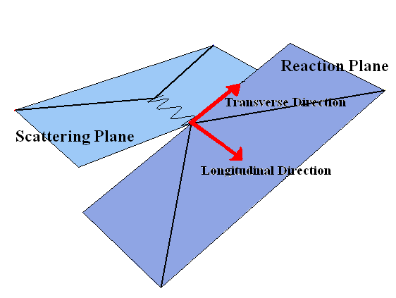
Figure 5. Kinematic Quantities. The longitudinal direction points in the direction of the exchanged photon, while the transverse direction is orthogonal to the longitudinal direction but within the scattering plane (left). The angle φ_{pq} is the angle between the scattering and reaction planes, while angle θ_{pq} is the angle between the longitudinal direction and the direction of the scattered proton (right).

In particle scattering, a differential cross section is defined by the probability to observe a scattered particle per solid angle unit if the target is irradiated by a flux of one particle per surface unit (see figure 6) For an electron scattering from a target, the cross section is described by:

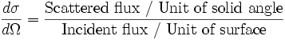 (1)
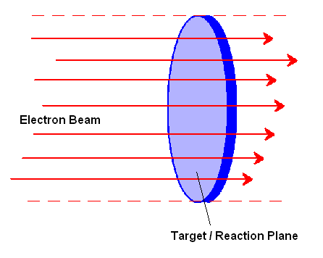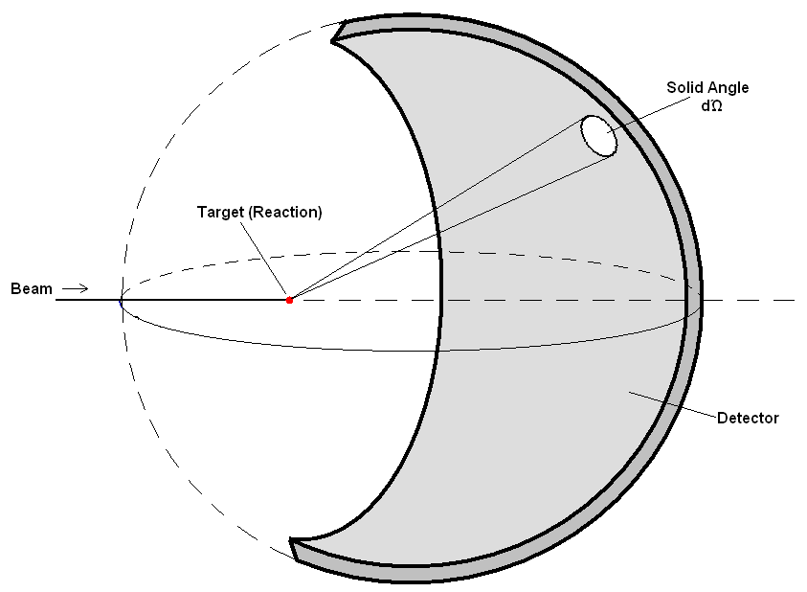
Figure 6. The cross section is a ratio of the scattered flux through a unit solid angle (right) to the incident flux per unit area (left).

For the D(e,e’p)n reaction, we detect both the scattered electron and proton and the cross section is as follows:
$\frac{d^{3}σ}{dωdΩ_{e}dΩ_{p}}=σ(θ,φ)=σ_{L}+σ_{T}+σ_{\text{LT}}\text{cos}(φ_{\text{pq}})+σ_{\text{TT}}\text{cos}(2φ_{\text{pq}})+hσ'_{\text{LT}}\text{sin}(φ_{\text{pq}})$
(1)

where h is the beam helicity, a quantity that is defined as the projection of the angular momentum of the particle (electron) onto its direction of motion. The σ terms are born out of the probability. The “L” and “T” subscripts denote the “longitudinal” and “transverse” directions; the longitudinal points in the direction of the exchanged photon, while the transverse is orthogonal to the longitudinal but also lies within the scattering plane (see figure 5). The other terms (LT, TT, and LT’) are cross terms. The helicity can have values ±1. For this reaction, we can extract the different φ-dependent terms in the cross section by taking advantage of the orthogonality of the sines and cosines. For example, to extract σ_{LT}, consider the following:
$⟨\text{cos}φ_{\text{pq}}⟩=\frac{\int_{0}^{2π}{σ(θ,φ_{\text{pq}})\text{cos}φ_{\text{pq}}{dφ}_{\text{pq}}}}{\int_{0}^{2π}{σ(θ,φ_{\text{pq}}){dφ}_{\text{pq}}}}=\frac{σ_{\text{LT}}}{2(σ_{L}+σ_{T})}=\frac{A_{\text{LT}}}{2}$

(2)

The asymmetry A_{LT} is proportional to σ_{LT} and less sensitive to acceptance corrections and other experimental effects which cancel in the ratio. My research examines this asymmetry A_{LT}. Equation 3 shows the expressions we use to determine the asymmetries in a kinematic bin in θ_{pq} where N is the total number of events.
$A_{\text{LT}}=\frac{\sum{\text{cos}}(φ_{\text{pq}})}{N}$

(3)

3.2 Perl Scripts and Simulating CLAS

In order to separate real physics results from artifacts of the detector we simulate the performance of CLAS. We start with a pair of scripts written in Perl, which is a general-purpose programming language that is useful in tying together systems and interfaces that were not specifically designed to inter-operate, and is also useful when converting and/or processing large amounts of data. These scripts execute a sequence of commands to run a number of different programs, manage files, etc. The scripts are executed on the 34-node supercomputing cluster in the University of Richmond’s nuclear physics laboratory.

In the simulation and analysis process, two event data banks are used: the “PART” bank contains the thrown events that are generated by the first program, QUEEG (Quasi-Elastic Electron Generator, see Table 1), before they are passed through the CLAS simulation GSIM. We essentially keep a copy of the events to be simulated and in doing so we have a baseline for analyzing the events that were processed in the simulation. A second “EVNT” bank contains these events; this bank represents the accepted actually made it through the detector and the analysis codes.

There are two Perl scripts used in the simulation process: the first of the scripts (submit_sim.pl) keeps track of which nodes on the Richmond supercomputing cluster are up and running, and then starts the simulation process by submitting the second script (run_queegsim_on_node.pl) as a batch job on those nodes. This second script runs a number of programs, performs file conversions, and manages files throughout the simulation process. A summary of the programs called by this script is given in Table 1. The appendix has printouts of both Perl scripts.

 | Program | Description
 | Simulation
1 | QUEEG | Quasi-Elastic Electron Generator – generates quasi-elastic electron events by creating electron 4-vectors. The term “quasi-elastic” is used to describe interactions where a photon is emitted and then exchanged for a nucleon.
2 | txt2part | txt2part – converts QUEEG output to BOS files. These are the PART data bank 4-vectors.
3 | GSIM | CLAS simulation program. This is the main program of the script. Output will be the EVNT data bank 4-vectors.
4 | gppjlab | Removes dead CLAS components such as dead drift chamber wires. Certain regions and/or components of CLAS are known to be faulty or not-working, so factor this into the simulation process by removing data that would normally come from these regions.
 | Analysis
5 | RECSIS | Event reconstruction program. This program takes the output and reconstructs the tracks of the particles within CLAS. This program is the same used to reconstruct tracks when analyzing the real data.
6 | nt10maker | nt10maker – convert EVNT and PART BOS data banks to hbook ntuples. This is a software package for physics analysis.
7 | h2root | h2root – converts hbook ntuples to root ntuples.
8 | eod5root | eod5root – local code for final analysis to extract histograms, asymmetries, etc.

Table 1. Summary of Perl script to run programs.

3.4 Track Vertex Shifts

Misalignments of the components of CLAS can create false asymmetries in the data. To investigate this issue, the data is simulated without true asymmetries (A_{LT} =0), but we include small shifts in the positions of the CLAS components in our simulation. The geometry of the track vertex is shown in Figure 7.

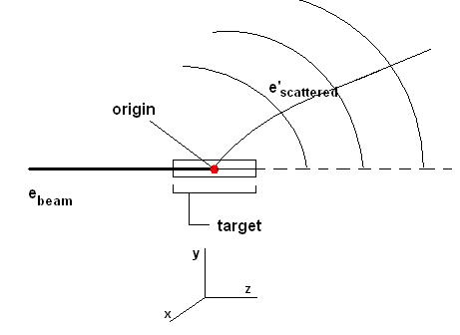
Figure 7. Track vertex geometry from side of CLAS. In the reaction, the vertex (the red point) is offset in the y-direction, and we duplicate this shift within our simulation process.

For example, we observe in real data that the vertex is offset as a result of these misaligned CLAS components (see Figure 8). If we observe that the vertex is offset in the y-direction by a distance b, then we attempt to reproduce it by shifting our (simulated) detector by the same distance b in the y-direction.

We measure these actual vertex shifts from the beamline along the z-axis from the real data. We provide the simulation with these shift values sector by sector. Therefore, we measure the shift from beamline in each sector independently. Figure 8 shows the shifts we observe in the data, which are then inserted manually into our simulation. The same plot is then generated from the simulated results (Figure 9). We fit both of these plots with a Gaussian curve, where f(v_{y}) is the number of counts and obeys the formula:
$f(v_{y})=N_{0}\text{exp}(−\frac{(v_{y}−v_{y0})}{2σ^{2}}$ (6)
where v_{y0} is the mean of the distribution and σ is the standard deviation. The mean offset in the v_{y}-direction from data is compared with that from the simulation. We can see from Table 2 that these values are consistent. The consistency mean our simulation is realistic and reproduces the behavior of CLAS.
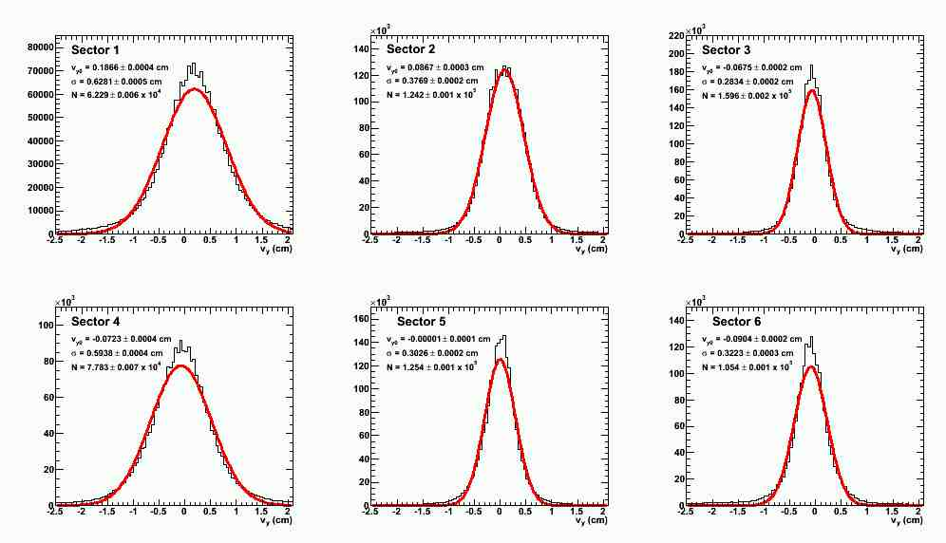
Figure 8. Plots from the y-component of the electron track vertex position for each CLAS sector taken from real data.

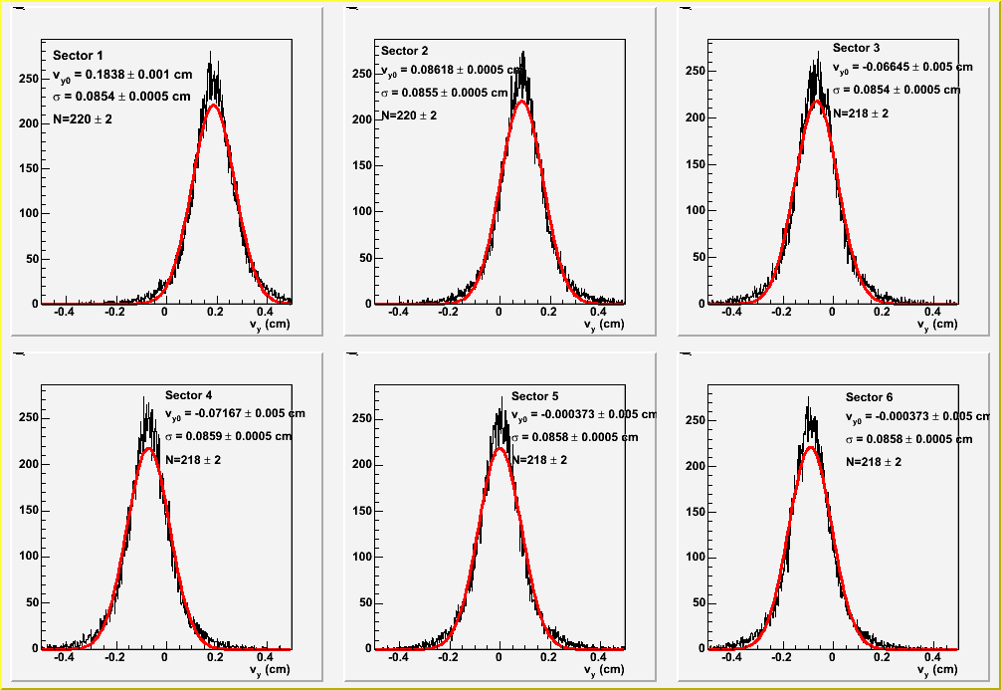
Figure 9. Plots from the y-component of the electron track vertex position for each CLAS sector taken from the simulation.

 | Mean Vertex Shift in v_{y} (cm)
Sector | From Data | After Simulation
1 | 0.1866 | 0.1838
2 | 0.0867 | 0.08618
3 | -0.065 | -0.06645
4 | -0.0723 | -0.07167
5 | -0.00001 | 0.000373
6 | -0.0904 | -0.09134

Table 2. Mean vertex offsets in v_{y}-direction.

5 Results and Conclusion

5.1 Results

The effect of the vertex shifts in the simulations on the asymmetries is shown in Figure 10. The simulations were run with A_{LT}=0 in the event generator. The red filled points represent the asymmetry of the thrown events. In other words, this is the asymmetry produced in the event generator before events have been processed through GSIM. This asymmetry is zero within its uncertainties. The open blue points show the asymmetry after events have gone through the simulation. The asymmetries are plotted versus p_{m}, which is defined as:
$$|\overset{→}{p_{m}}|=|\overset{→}{p_{e}}−\overset{→}{p_{e'}}−\overset{→}{p_{p}}|$$
where $\overset{→}{p_{e}}$is the momentum of the incoming electron, $\overset{→}{p_{e'}}$is the momentum of the scattered electron, and $\overset{→}{p_{p}}$is the momentum of the observed proton. The size of the asymmetry is large: for comparison, consider Figure 11, which shows A_{LT} from data. The magnitude of the largest asymmetry is around 0.2 in the data and 0.14 in the simulation. Understanding and correcting for this false asymmetry will be an essential step in obtaining significant results from our data.

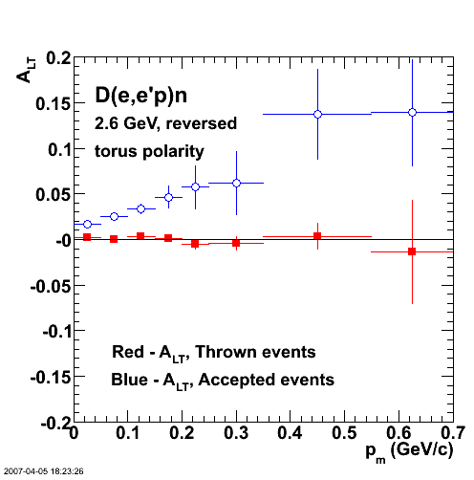
Figure 10. A false A_{LT} asymmetry appears in the simulated shifted events, but not in the thrown events.
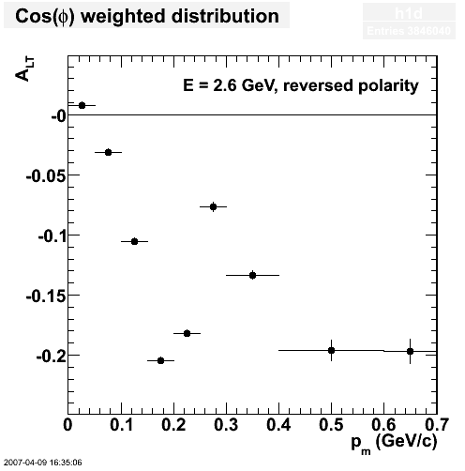
Figure 11. A_{LT} asymmetry which appears in real data.

5.2 Conclusions

We have produced working scripts to control and execute the CLAS simulation package GSIM on the Richmond supercomputing cluster. These scripts will be useful in further research and other future projects to study and investigate other aspects of CLAS experiments.

We observe a significant false asymmetry in the simulations when the asymmetry in the thrown data is zero. This false asymmetry appears after the generated events are processed in GSIM, and therefore appears to be an artifact of the CLAS detector. We are now trying to understand the source of this effect.

7 References

1. T.P. Smith, “Hidden Worlds,” (2003)
2. G.P.Gilfoyle, R. Burrell. K. Gill, “Measuring the Fifth Structure Function in d(e,e’p)n,” (2006)
3. G.P.Gilfoyle, “Hunting for Quarks,” (2006)
4. R.Burrell, K. Gill, G.P. Gilfoyle, “CLAS Simulations for the E5 Data Set,” (poster) (2006).
5. Wikipedia, “Standard Model,” (2007), http://en.wikipedia.org/wiki/Standard_model
6. Wikipedia, “Quantum Chromodynamics,” (2007), http://en.wikipedia.org/wiki/Quantum_chromodynamics
7. Wikipedia, “Cross Section (physics),” (2007), http://en.wikipedia.org/wiki/Cross_section_%28physics%29
8. Thomas Jefferson Lab National Accelerator Facility Website, (2007), www.jlab.org
9. “The Particle Adventure,” (2007), http://particleadventure.org/index.html

6 Appendix : Perl Scripts

1. submit_sim.pl
This perl script keeps track of which nodes on the Richmond supercomputing cluster are up and running, and then starts the simulation process by submitting the second script (run_queegsim_on_node.pl, see part 2 of this appendix) on those nodes.

#!/usr/bin/perl
#
# script to simulate E5 data on the Richmond cluster. it does
# NOT use beomap to allocate node numbers; it just picks them
# in numerical order and skips any down nodes.
# - gpg
# run this by executing 'submit_sim.pl n' at the command line
# where n is 1 or 2 depending on which event generator you are using.
# n = 1 - celeg
# 2 - queeg
#

@option = @ARGV;
$options = @option;
$evtgen = $option[0];
#
# make sure the user has chosen an event generator.
#
$len = length($evtgen);
if ($len == 0) {
die "No event generator defined!!!!!!!\n";
}
#
# do housekeeping on the master.
#
system("rm /home/rb3cf/eodsim/eodsim/run/results/*");
system("rm /scratch/rb3cf/e5/sim_log*");
system("rm /scratch/rb3cf/e5/gsim_log*");
#
# get rid of old simulation stuff on the remote nodes.
#
system("bpsh -a rm -r /scratch/rb3cf/e5/sim/");
#
# stuff for picking the static slave node.
#
$number_of_nodes=11;
$first_node=0;
#
# list of down nodes. nodes 52-68 do not exist.
#
@dead_nodes = (4,6,13,20,22,23,24,27,30,36,37,38,41,42,44,45,46,48,49,52,53,54,55,56,57,58,59,60,61,62,63,64,65,66,67,68,69,70);
$number_of_dead_nodes = @dead_nodes;
#
# loop over the nodes.
#
for ($inode=0; $inode < $number_of_nodes; $inode++) {
#
# check for a bad node.
#
$node_is_dead = 0;
for ($i = 0; $i < $number_of_dead_nodes; $i++) {
if ($inode == $dead_nodes[$i]) {
$node_is_dead = 1;
}
}
if ($node_is_dead == 0) {
#
# get the batch command file ready to submit the job and let're rip.
# clean up is done in run_sim_on_node.pl since we have to wait for
# root to get done on the slave.
#
open(OUT,">run_sim");
# print OUT "export ROOTSYS=/usr/root/4.02.00/ \n";
# print "export ROOTSYS=/usr/root/4.02.00/ \n";
# print OUT "export ROOTSYS=/usr/root/4.00.08/ \n";
# print "export ROOTSYS=/usr/root/4.00.08/ \n";
if ($evtgen == 1) {
print OUT "./run_celegsim_on_node.pl $inode \n";
print " \n";
print "./run_celegsim_on_node.pl $inode \n";
} elsif ($evtgen == 2) {
print OUT "./run_queegsim_on_node.pl $inode \n";
print " \n";
print "./run_queegsim_on_node.pl $inode \n";
} else {
print "YIIIKES!!! No event generator chosen.\n";
}
close(OUT);
system("batch -q a -f run_sim");
print "Sleep for 5 seconds.\n";
sleep 5;
print "Submit on node $inode for simulation.\n";
}
}
# end of for loop over nodes.

2. run_queegsim_on_node.pl
Below is the Perl script “run_queegsim_on_node.pl”. This script runs a number of programs, performs file conversions, and manages files throughout the simulation process.

#!/usr/bin/perl
#
# script for running celeg-gsim-recsis on a slave node of the cluster.
# called from submit_sim.pl.
# - gpg 04/10/06
#
# set up the environment including the node
# assignments that come from the arguments of the
# script.
#
# usage: run_sim_on_node.pl n where n is the node number.

@option = @ARGV;
$options = @option;

$NODE = $option[0];

# set the number of events.
$NEVNT=100000; #changed from 1000 to 100000 by rusty 3/25
# number of loops while waiting for recsis in batch to get done. see line 155.
$NLOOPS=51;

# cluster stuff.
system("setenv ROOTSYS /usr/root/PRO");
system("setenv NO_LOCAL 1");
system("source /home/clas/builds/release-4-11/packages/cms/rich.cshrc");
system("setenv CLAS_CALDB_HOST 192.168.1.1");
system("setenv RECSIS_DONE 0");
system("setenv E5_SOURCE /home/rb3cf/eod/queeg.v3/");

# Make a working directory and go to it
# NOTE: Make this on the master as well as a place holder
# no actual data goes to the placeholder on the master.

system("bpsh $NODE mkdir -p /scratch/rb3cf/e5/sim/${NODE} >| /scratch/rb3cf/e5/sim_log${NODE} 2>&1");
system("mkdir -p /scratch/rb3cf/e5/sim/${NODE}/ >> /scratch/rb3cf/e5/sim_log${NODE} 2>&1");
system("cd /scratch/rb3cf/e5/sim/${NODE}");
system("echo 'Run for $NEVNT events.' >> /scratch/rb3cf/e5/sim_log${NODE} 2>&1");

# start QUEEG for positive helicity. ******************************************************
#
# Housekeeping and monitoring information for queeg.

system("echo 'start QUEEG on node $NODE for positive helicity. *****************' >> /scratch/rb3cf/e5/sim_log${NODE} 2>&1");
system("echo 'doing housekeeping on node $NODE.'");
system("echo '\ndoing QUEEG housekeeping on node $NODE for positive helicity.' >> /scratch/rb3cf/e5/sim_log${NODE} 2>&1");
system("cd /scratch/rb3cf/e5/sim/$NODE/");
chdir("/scratch/rb3cf/e5/sim/$NODE/");
system("rm /scratch/rb3cf/e5/sim_log${NODE}");
system("bpsh $NODE rm /scratch/rb3cf/e5/sim/${NODE}/queegout.A00");
system("bpsh $NODE rm /scratch/rb3cf/e5/sim/${NODE}/*.rzn");
system("date >> /scratch/rb3cf/e5/sim_log${NODE} 2>&1");
system("pwd >> /scratch/rb3cf/e5/sim_log${NODE} 2>&1");

# run queeg for positive helicity.

system("echo 'run QUEEG in my area on node $NODE for positive helicity.'");
system("echo '\nrun QUEEG in my area on node $NODE for positive helicity and N=$NEVNT.'>> /scratch/rb3cf/e5/sim_log${NODE} 2>&1");
system("bpsh $NODE /home/gilfoyle/bin/Linux/queeg -o queegsim.dat -E 2.558 -I 2250. -N $NEVNT -F 0.0 -R >> /scratch/rb3cf/e5/sim_log${NODE} 2>&1");
system("date >> /scratch/rb3cf/e5/sim_log${NODE} 2>&1");

# put the helicity in a file for later use.

system("bpsh $NODE rm /scratch/rb3cf/e5/sim/$NODE/helicity_sign.dat");
system("bpcp /home/rb3cf/eodsim/eodsim/run/positive_helicity.dat $NODE:/scratch/rb3cf/e5/sim/${NODE}/helicity_sign.dat");

# convert the text output of queeg to BOS files.

system("echo '\nstart TXT2PART on node $NODE. *****************' >> /scratch/rb3cf/e5/sim_log${NODE} 2>&1");
system("echo 'convert the text output of queeg to BOS files on node $NODE.'");
system("echo 'convert the text output of queeg to BOS files node $NODE.' >> /scratch/rb3cf/e5/sim_log${NODE} 2>&1");
system("cd /scratch/rb3cf/e5/sim/$NODE/");
system("bpsh $NODE /home/gilfoyle/bin/Linux/txt2part -oqueegout.A00 >> /scratch/rb3cf/e5/sim_log${NODE} 2>&1");
system("date >> /scratch/rb3cf/e5/sim_log${NODE} 2>&1");

# start GSIM. ********************************************************
#
# GSIM housekeeping and monitoring information.

system("date >> /scratch/rb3cf/e5/gsim_log${NODE} 2>&1");
system("echo '\nstart GSIM on node $NODE. *****************' >> /scratch/rb3cf/e5/sim_log${NODE} 2>&1");
system("echo 'doing housekeeping on node $NODE.'");
system("echo 'doing GSIM housekeeping on node $NODE.' >> /scratch/rb3cf/e5/sim_log${NODE} 2>&1");
system("cd /scratch/rb3cf/e5/sim/$NODE/");
chdir("/scratch/rb3cf/e5/sim/$NODE/");
system("bpsh $NODE rm /scratch/rb3cf/e5/sim/$NODE/gsimout.A00");
system("bpsh $NODE rm /scratch/rb3cf/e5/sim/$NODE/ffread.in");
system("bpsh $NODE rm /scratch/rb3cf/e5/sim/$NODE/gsim_log${NODE}");
system("pwd >> /scratch/rb3cf/e5/sim_log${NODE} 2>&1");

# move the gsim input file to the slave node.

system("bpcp /home/rb3cf/eodsim/eodsim/run/ffread.in $NODE:/scratch/rb3cf/e5/sim/${NODE}/ffread.in");

# run gsim. use a log file just for gsim to handle the buffered output.

system("date >> /scratch/rb3cf/e5/sim_log${NODE} 2>&1");
system("echo 'run GSIM on node $NODE in my area.'");
system("echo 'run my gsim on node $NODE.'>> /scratch/rb3cf/e5/sim_log${NODE} 2>&1");
system("bpsh $NODE /home/gilfoyle/bin/Linux/gsim_bat -ffread ffread.in -mcin 'queegout.A00' -kine 1 -bosout gsimout >| /scratch/rb3cf/e5/gsim_log${NODE} 2>&1");
system("echo 'GSIM is done.'>> /scratch/rb3cf/e5/sim_log${NODE} 2>&1");
system("date >> /scratch/rb3cf/e5/gsim_log${NODE} 2>&1");
system("date >> /scratch/rb3cf/e5/sim_log${NODE} 2>&1");

# start GPP. ********************************************************
#
# GPP housekeeping and monitoring information.

system("echo '\nstart GPP on node $NODE. *****************' >> /scratch/rb3cf/e5/sim_log${NODE} 2>&1");
system("echo 'doing housekeeping on node $NODE.'");
system("echo 'doing GPP housekeeping on node $NODE.' >> /scratch/rb3cf/e5/sim_log${NODE} 2>&1");
system("cd /scratch/rb3cf/e5/sim/$NODE/");
chdir("/scratch/rb3cf/e5/sim/$NODE/");
system("bpsh $NODE rm /scratch/rb3cf/e5/sim/$NODE/gppout.A00");
system("bpsh $NODE rm /scratch/rb3cf/e5/sim/$NODE/gppout.hbook");
system("pwd >> /scratch/rb3cf/e5/sim_log${NODE} 2>&1");

# run GPP.

system("date >> /scratch/rb3cf/e5/sim_log${NODE} 2>&1");
system("echo 'run GPP in my area on node $NODE.'");
system("echo 'run my GPP on node $NODE.'>> /scratch/rb3cf/e5/sim_log${NODE} 2>&1");
system("bpsh $NODE /home/gilfoyle/bin/Linux/gppjlab -ogppout.A00 gsimout.A00 >> /scratch/rb3cf/e5/sim_log${NODE} 2>&1");
system("date >> /scratch/rb3cf/e5/sim_log${NODE} 2>&1");

# start RECSIS. ********************************************************
#
# RECSIS housekeeping and monitoring information.

system("echo '\nstart RECSIS on node $NODE. *****************' >> /scratch/rb3cf/e5/sim_log${NODE} 2>&1");
system("echo 'doing RECSIS housekeeping on node $NODE.' >> /scratch/rb3cf/e5/sim_log${NODE} 2>&1");
system("cd /scratch/rb3cf/e5/sim/$NODE/");
chdir("/scratch/rb3cf/e5/sim/$NODE/");
system("bpsh $NODE rm /scratch/rb3cf/e5/sim/$NODE/recsisout.A00");
system("bpsh $NODE rm /scratch/rb3cf/e5/sim/$NODE/histfile");
system("bpsh $NODE rm /scratch/rb3cf/e5/sim/$NODE/gpg5logfile");
system("bpsh $NODE rm /scratch/rb3cf/e5/sim/$NODE/anamonhist");
system("bpsh $NODE rm /scratch/rb3cf/e5/sim/$NODE/recsis5.tcl");
system("bpsh $NODE rm /scratch/rb3cf/e5/sim/$NODE/recsis_done");

# copy the RECSIS input file to the slave node.

system("bpcp /home/rb3cf/eodsim/eodsim/run/recsis5.tcl $NODE:/scratch/rb3cf/e5/sim/${NODE}/recsis5.tcl");

# run recsis.

system("echo 'run RECSIS in my area on node $NODE.'");
system("bpsh $NODE rm /scratch/rb3cf/e5/sim/${NODE}/recsis_done >> /scratch/rb3cf/e5/sim_log${NODE} 2>&1");
system("bpsh $NODE ls -la /scratch/rb3cf/e5/sim/${NODE}/ >> /scratch/rb3cf/e5/sim_log${NODE} 2>&1");
system("date >> /scratch/rb3cf/e5/sim_log${NODE} 2>&1");
system("echo 'run my recsis on node $NODE.'>> /scratch/rb3cf/e5/sim_log${NODE} 2>&1");
system("bpsh $NODE /home/gilfoyle/bin/Linux/user_ana -t recsis5.tcl -b > /dev/null & >> /scratch/rb3cf/e5/sim_log${NODE} 2>&1");
system("date >> /scratch/rb3cf/e5/sim_log${NODE} 2>&1");
#
# recsis is running in background so we wait for a file (recsis_done) to appear
# created in user_erun.F at the end of the analysis before you start the next
# stage of the analysis.
#
$icounter=0;
$recsis_done_file=0;
while ($recsis_done_file ne "/scratch/rb3cf/e5/sim/${NODE}/recsis_done" && $icounter < $NLOOPS) {
$recsis_done_file = `bpsh $NODE ls -1 /scratch/rb3cf/e5/sim/${NODE}/recsis_done`;
chomp$recsis_done_file;
print("Sleeping for 60 seconds on node $NODE! recsis_done_file = $recsis_done_file .\n");
sleep(60);
$icounter++;
print("loop number $icounter on node $NODE waiting for recsis to finish.\n");
system("echo 'loop $icounter on node $NODE waiting for recsis to finish.' >> /scratch/rb3cf/e5/sim_log${NODE} 2>&1");
system("bpsh $NODE ls -la /scratch/rb3cf/e5/sim/${NODE}/recsis_done >> /scratch/rb3cf/e5/sim_log${NODE} 2>&1");
}
system("date >> /scratch/rb3cf/e5/sim_log${NODE} 2>&1");
#
# sleep for a few more seconds to let recsis finish and then add the recsis log to this log.
#
sleep(5);
system("bpsh $NODE cat /scratch/rb3cf/e5/sim/${NODE}/gpgsimlogfile >> /scratch/rb3cf/e5/sim_log${NODE} 2>&1");
system("date >> /scratch/rb3cf/e5/sim_log${NODE} 2>&1");

print "Continuing to run nt10maker on node $NODE.";

# start NT10MAKER. ********************************************************
#
# NT10MAKER housekeeping and monitoring information.

system("echo '\nstart NT10MAKER on node $NODE. *****************' >> /scratch/rb3cf/e5/sim_log${NODE} 2>&1");
system("echo 'doing NT10MAKER housekeeping on node $NODE.'");
system("bpsh $NODE rm /scratch/rb3cf/e5/sim/$NODE/nt10outevnt.hbook");
system("bpsh $NODE rm /scratch/rb3cf/e5/sim/$NODE/nt10outevnt.root");
system("bpsh $NODE rm /scratch/rb3cf/e5/sim/$NODE/nt10outpart.hbook");
system("bpsh $NODE rm /scratch/rb3cf/e5/sim/$NODE/nt10outpart.root");

# run NT10MAKER to translate EVNT and PART banks. use recsisout.A00 for EVNT and queegout.A00 for PART bank.

system("echo 'run NT10MAKER on node $NODE.'");
system("echo 'run NT10MAKER on node $NODE.'>> /scratch/rb3cf/e5/sim_log${NODE} 2>&1");
system("cd /scratch/rb3cf/e5/sim/$NODE/");
chdir("/scratch/rb3cf/e5/sim/$NODE/");
system("echo 'run NT10MAKER on node $NODE to get EVNT bank.'");
system("echo 'run NT10MAKER on node $NODE to get EVNT bank.'>> /scratch/rb3cf/e5/sim_log${NODE} 2>&1");
system("bpsh $NODE /home/clas/builds/PRODUCTION/bin/LinuxRH9//nt10maker -t1 -ont10outevnt.hbook recsisout.A00 >> /scratch/rb3cf/e5/sim_log${NODE} 2>&1");
system("date >> /scratch/rb3cf/e5/sim_log${NODE} 2>&1");
system("echo 'run NT10MAKER on node $NODE to get PART bank.'");
system("echo 'run NT10MAKER on node $NODE to get PART bank.'>> /scratch/rb3cf/e5/sim_log${NODE} 2>&1");
system("bpsh $NODE /home/clas/builds/PRODUCTION/bin/LinuxRH9//nt10maker -t2 -ont10outpart.hbook queegout.A00 >> /scratch/rb3cf/e5/sim_log${NODE} 2>&1");
system("date >> /scratch/rb3cf/e5/sim_log${NODE} 2>&1");

# start H2ROOT. ********************************************************
#
# H2ROOT housekeeping and monitoring information.

system("echo '\nstart H2ROOT on node $NODE. *****************' >> /scratch/rb3cf/e5/sim_log${NODE} 2>&1");
system("echo 'doing H2ROOT housekeeping on node $NODE.'");
system("bpsh $NODE rm /scratch/rb3cf/e5/sim/$NODE/nt10outevnt.root");
system("bpsh $NODE rm /scratch/rb3cf/e5/sim/$NODE/nt10outpart.root");

# run H2ROOT to translate EVNT and PART banks in recsisout.A00.

system("echo 'run H2ROOT on node $NODE.'");
system("date >> /scratch/rb3cf/e5/sim_log${NODE} 2>&1");
system("echo '\nrun H2ROOT on node $NODE for EVNT banks.'>> /scratch/rb3cf/e5/sim_log${NODE} 2>&1");
system("bpsh $NODE /usr/root/PRO/bin/h2root nt10outevnt.hbook nt10outevnt.root >> /scratch/rb3cf/e5/sim_log${NODE} 2>&1");
system("echo '\nrun H2ROOT on node $NODE for PART banks.'>> /scratch/rb3cf/e5/sim_log${NODE} 2>&1");
system("bpsh $NODE /usr/root/PRO/bin/h2root nt10outpart.hbook nt10outpart.root >> /scratch/rb3cf/e5/sim_log${NODE} 2>&1");
system("date >> /scratch/rb3cf/e5/sim_log${NODE} 2>&1");

# start ROOT. ********************************************************
#
# ROOT housekeeping and monitoring information.

system("echo '\nstart ROOT on node $NODE. *****************' >> /scratch/rb3cf/e5/sim_log${NODE} 2>&1");
system("echo 'doing ROOT housekeeping on node $NODE.' >> /scratch/rb3cf/e5/sim_log${NODE} 2>&1");
system("bpsh $NODE rm /scratch/rb3cf/e5/sim/$NODE/eodsim_hists.root");
system("bpcp /home/rb3cf/eodsim/eodsim/evnt/run_evnt.C $NODE:/scratch/rb3cf/e5/sim/$NODE/");
system("bpcp /home/rb3cf/eodsim/eodsim/evnt/evnt_data_filenames.dat $NODE:/scratch/rb3cf/e5/sim/$NODE/");
system("bpcp /home/rb3cf/eodsim/eodsim/part/run_part.C $NODE:/scratch/rb3cf/e5/sim/$NODE/");
system("bpcp /home/rb3cf/eodsim/eodsim/part/part_data_filenames.dat $NODE:/scratch/rb3cf/e5/sim/$NODE/");

# run ROOT for EVNT bank analysis.

system("date >> /scratch/rb3cf/e5/sim_log${NODE} 2>&1");
system("echo 'run my ROOT on node $NODE for EVNT bank analysis.'");
system("echo '\nrun my ROOT on node $NODE for EVNT bank analysis.'>> /scratch/rb3cf/e5/sim_log${NODE} 2>&1");
system("bpsh $NODE /home/rb3cf/eodsim/eodsim/evnt/evntroot -b -q /scratch/rb3cf/e5/sim/$NODE/run_evnt.C >> /scratch/rb3cf/e5/sim_log${NODE} 2>&1");
#rename root output file to prevent overwriting.
system("bpsh $NODE mv /scratch/rb3cf/e5/sim/$NODE/sim_hists.root /scratch/rb3cf/e5/sim/$NODE/sim_evnthists.root >> /scratch/rb3cf/e5/sim_log${NODE} 2>&1");
system("date >> /scratch/rb3cf/e5/sim_log${NODE} 2>&1");

# run ROOT for PART bank analysis.

system("echo 'run my ROOT on node $NODE for PART bank analysis.'");
system("echo '\nrun my ROOT on node $NODE for PART bank analysis.'>> /scratch/rb3cf/e5/sim_log${NODE} 2>&1");
system("bpsh $NODE /home/rb3cf/eodsim/eodsim/part/partroot -b -q /scratch/rb3cf/e5/sim/$NODE/run_part.C >> /scratch/rb3cf/e5/sim_log${NODE} 2>&1");
#rename root output file to prevent overwriting.
system("bpsh $NODE mv /scratch/rb3cf/e5/sim/$NODE/sim_hists.root /scratch/rb3cf/e5/sim/$NODE/sim_parthists.root >> /scratch/rb3cf/e5/sim_log${NODE} 2>&1");
system("date >> /scratch/rb3cf/e5/sim_log${NODE} 2>&1");

# save results.

system("bpcp $NODE:/scratch/rb3cf/e5/sim/$NODE/gppout.A00 /home/rb3cf/eodsim/eodsim/run/results/gppouthpos${NODE}.A00 >> /scratch/rb3cf/e5/sim_log${NODE} 2>&1");
system("bpcp $NODE:/scratch/rb3cf/e5/sim/$NODE/sim_evnthists.root /home/rb3cf/eodsim/eodsim/run/results/sim_evnthists${NODE}.root >> /scratch/rb3cf/e5/sim_log${NODE} 2>&1");
system("bpcp $NODE:/scratch/rb3cf/e5/sim/$NODE/sim_parthists.root /home/rb3cf/eodsim/eodsim/run/results/sim_parthists${NODE}.root >> /scratch/rb3cf/e5/sim_log${NODE} 2>&1");

system("date >> /scratch/rb3cf/e5/sim_log${NODE} 2>&1");

system("date >> /scratch/rb3cf/e5/sim_log${NODE} 2>&1");
system("echo '\nDONE!! ' >> /scratch/rb3cf/e5/sim_log${NODE} 2>&1");

