Investigating Asymmetries in the
D(e, e’p)n Reaction
January 10, 2008
Kuri Gill (G.P. Gilfoyle)

Abstract

We have simulated and measured the asymmetries for the A_{TT} component of the D(e,e’p)n reaction. The cross section for the D(e,e’p)n reaction has four terms. In our research we are concerned with one term, σ_{TT} which is the fourth term which is the interference between the real and imaginary parts of the transverse component of the cross section. To isolate this term we define an asymmetry A_{TT} which is a ratio to reduce our sensitivity to the acceptance of the detector, the runtime, etc. This reaction was measured in the CEBAF Large Acceptance Spectrometer (CLAS) at the Thomas Jefferson National Accelerator Facility in Newport News, Va. We used the program GSIM to simulate CLAS and study the effect of the detector misalignments on A_{TT}. We have inserted the vertex shifts found in the real data into the simulations to determine if the vertex shifts cause a false asymmetry. We observed a false asymmetry in A_{TT} and studied its sensitivity to uncertainties in the misalignments.

Introduction

What is the world made of? Throughout the last 200 years we have seen a vast increase in knowledge of matter due to advances in technology and increased research. We have progressed from thinking that the most fundamental particles are atoms, to finding the much smaller constituents. We now know that normal matter consists of quarks and gluons bound by the exchange of force carriers, and all the known matter in the universe can be made with these particles. Nuclear and particle physicists have created the Standard Model to classify and describe these fundamental particles¹.

This paper will first provide a background of the Standard Model and Quantum Chromodynamics and the nuclear physics program at Thomas Jefferson National Laboratory where my research under Dr. Gilfoyle has been based. It will describe the Continuous Electron Beam Accelerating Facility (CEBAF) and the CLAS (CEBAF Large Acceptance Spectrometer) detector. It will discuss the cross section for the D(e,e’p)n reaction and why it is important. The notation D(e,e’p)n refers to a deuteron (D) target being hit by an electron (e), which results in a scattered electron (e’) and a proton (p), and leaving a neutron (n) behind. Our work specifically focused on the σ_{TT} component of the cross section. To reduce systematic uncertainties, we created an asymmetry, A_{TT}. We use simulations to mimic CLAS to determine which results are real physics ones and which results are artifacts of the detector. This paper will discuss the scripts used to run GSIM (the simulation program for CLAS). It will also discuss the measured vertex shifts in CLAS components and how these shifts may create a false uncertainty in the detector. Finally, I have found that there is a significant, non-zero asymmetry, and will show how it affects the results from the detector.

Standard Model and QCD
Figure 1: Fundamental Constituents of Matter²
Figure 2: Force Carriers²

Figure 1 shows a table of the fundamental constituents of the known matter in the universe. There are twelve particles, six leptons and six quarks. These particles are called fermions, which means they have half integer spin and obey the Pauli Exclusion Principle. While both quarks and leptons have ½ integer spin, quarks are only found in groups and combine to create particles such as protons and neutrons. Leptons are found independently in nature, and include muons and electrons. Figure 2 shows a table of the particles that transmit the fundamental forces of nature. These particles are categorized by integer spin and do not obey the Pauli Exclusion Principle. Those forces are the unified electroweak force and the strong(color) force. The Unified Electroweak force is carried by the photon, and the W⁻, W⁺, and Z⁰ particles. The strong force is carried by the gluon, which ‘glues” quarks together to create matter. There is a theorized graviton, which would be behind the force of gravity, but it has not yet been discovered. Bosons are force carrying particles with integer spin; they construct the forces that bind fermions together. It is this interaction with fermions that creates matter¹.

The theory describing the so called color force that binds quarks together is Quantum Chromodynamics or QCD (2004 Nobel Prize in Physics: D. Cross, D. Politzer, F.Wilczek) ³. As mentioned earlier quarks are only found in groups that consist of two or three quarks each. The theory is based on the fact that all known particles are color singlets meaning they have no net color charge. Quarks color charge bears no relations to visual color, but it is a good way to explain the three kinds of “color charge”. A particle can be created with three primary “colors” or with a “color” and an “anti-color” which like the primary colors, will create white light or no net color charge. Quarks are the color charged particles that create the larger particles. Therefore, a particle can be made with three quarks or with a quark and an anti-quark⁴.

Quantum Chromodynamics has two very interesting qualities. The first is Confinement. QCD explains the observation that quarks can not be seen individually because as the distance between particles increases the potential between them increases at a constant rate. The particles can never escape the potential well. As quarks are pulled farther and farther apart the energy stored in the field continue to increase. The force (which is the derivative of the potential) pulling them together is constant after a certain distance. This can be seen as the graph rises at a constant rate after a distance of .3 fm. The second property is Asymptotic Freedom, which states that as the quarks move closer together, the force between them goes to zero. This is helpful because even though we cannot extract a single quark alone, we can observe their properties by bringing it very close to other quarks and making the force exerted on it essentially zero. This too can be seen on the graph below, as the quarks become closer, the potential drops to zero. The weakness of the force permits us to use theoretical methods (perturbation theory) that fail when the quarks are far apart⁵.
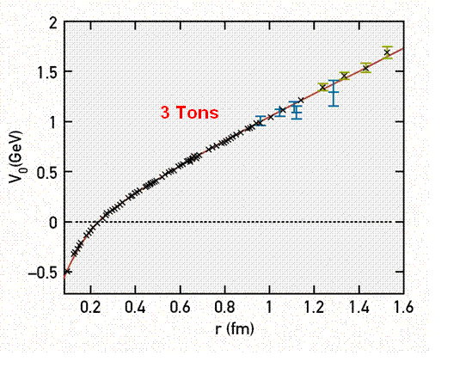
Figure 3: Confinement (theoretical calculation of potential vs. distance for two fixed quarks). As the quarks get further apart, the potential rises linearly, and the force is constant at 3 tons⁶.

Thomas Jefferson National Accelerator Facility

The data were collected at the Thomas Jefferson National Accelerator Facility (or JLab). JLab is a facility funded by the U.S Department of Energy. Its primary mission is to conduct basic research of the atom’s nucleus at the quark level. JLab features CEBAF, the Continuous Electron Beam Accelerating Facility. It consists of a 7/8th of a mile racetrack shaped track 25 feet underground. It can produce beams with energy up to 6 GeV. An electron can be accelerated up to five times around the track before it is sent to one of the three halls where the beam collides with targets and scatter particles through different detectors⁷.

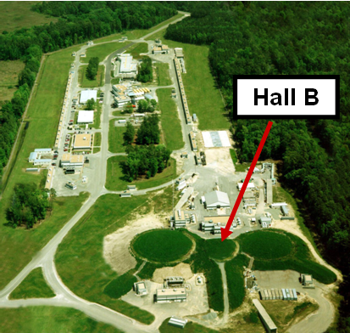
Figure 4: Jefferson Lab, Newport News, Va⁷

The CEBAF Large Acceptance Spectrometer

In Hall B is CLAS, the CEBAF Large Acceptance Spectrometer. CLAS is a 45-ton, $50 million radiation detector used to detect electrons, protons, pions and other subatomic particles. CLAS is unique in that it is a nearly 4π detector so it can detect almost all of the particles created in a nuclear reaction. It collects information about charge, momentum, velocity and energy allowing us to have a digital snapshot of the event that occurred⁸.

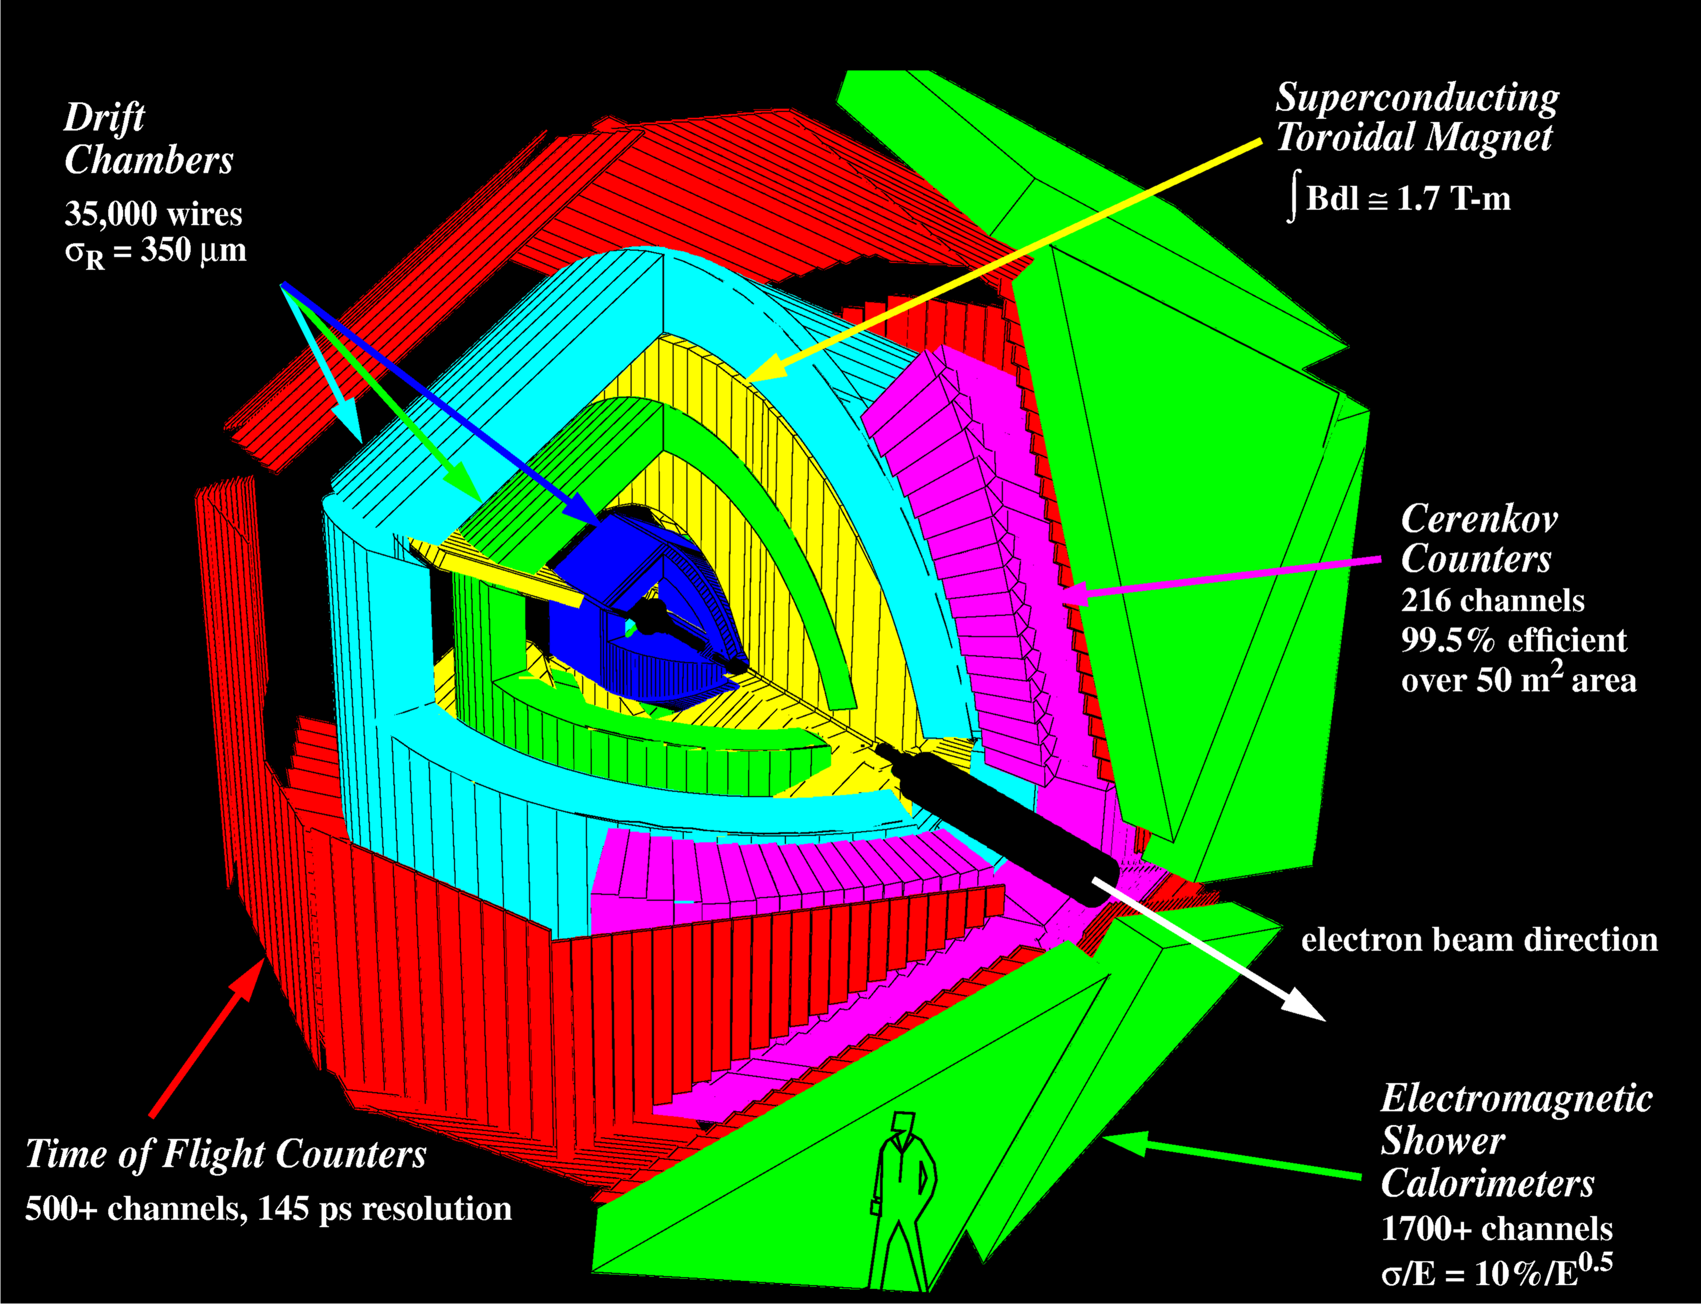
Figure 5: The layers of CLAS⁷. The three regions of drift chambers are dark blue, green and light blue and the toroidal magnet is yellow. The Cerekov counters are pink, the Time of Flight Counters are red and the Shower Calorimeters are green. Also notice the size of CLAS compared to a person.

CLAS is segmented into six identical sectors each consisting of many layers. The closest to the target (and the beam line) are the drift chambers (shown by the dark blue, green and light blue regions in Figure 5). They consist of 32,000 sense wires each with a diameter of 30 micrometers. The scattered particles pass through a gas and leave a trail of ions. The ions drift to sense wires creating a burst of current. These hits are used to reconstruct the trajectory of the particle⁸.

The next layer for forward-angle particles consists of the Cerenkov Counters. In Figure 5 the Cerenkov Counters are in the pink region. These counters produce light when a particle moving close to the speed of light in air passes into the detector where the speed of light is much slower so the particle is moving faster than the speed of light in the medium. These particles slow down and dump the excess energy in the form of light. Since the lighter electrons are more likely to be moving faster, the Cerenkov Counters can help distinguish electrons from much heavier particles such as pions which are slower⁸.

The next layer is the Time of Flight (TOF) system. Figure 5 represents this component in the red region. It consists of plastic scintillators which provides a very accurate flight time for each particle. This is achieved with over 3000 Photo-Multiplier Tubes which are so sensitive they can detect a single photon. The very accurate time produced by these Scintillators is important for three reasons. The first is that the beam is chopped into micropulses and sent to the halls. The very accurate time stamp is helpful for determining which event belongs to which micropulse. This gives us a start time for the TOF measurement. Also we can use this to determine the velocity of a particle since we know the path length from the trajectory measured in the drift chambers. Using the momentum extracted from the trajectory as described below, we can extract the mass of the particle⁸.

The next layer consists of the electromagnetic calorimeters which are made of many alternating layers of lead and scintillating plastic. The outer green region of Figure 5 holds the calorimeters. The calorimeter stops all charged particles and measures the energy of the particle. Each particle creates a shower of other particles. These secondary particles then produce light in the scintillators which is related to the energy of the incoming particle⁸.

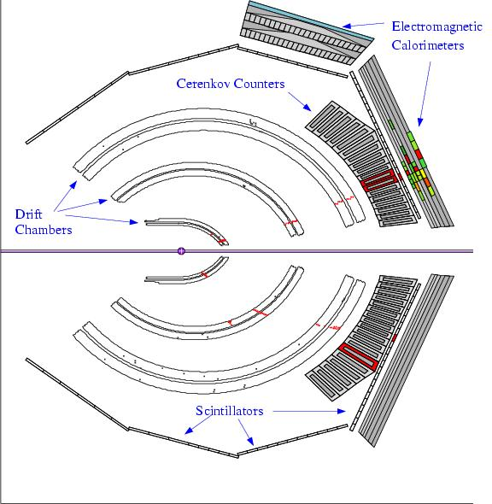
Figure 6: An event in CLAS⁸

Figure 6 shows an event. The red crosses in the drift chambers show where the particle has passed through. These trails help determine the trajectory of the particles⁸.

CLAS includes a toroidal magnet that causes charged particles to curve as they pass through the region 2 drift chambers (See the yellow components in Figure 5). The magnetic field is created by six superconducting coils. Particles with higher momentum bend much less than particles with lower momentums. The particle on the top of Figure 6 is negatively-charged electron and bends outward. The track in the lower half of Figure 6 is positive because it bends inward⁸.

The combination of all of the layers allows us to determine the velocity, momentum, energy, mass, and scattering angle of particles which allows us to identify the particles which are present in the scattering reaction⁸.

Asymmetries

In the D(e, e’p)n reaction we measure the out-of-plane properties of the nuclear cross section which have never been determined in this energy region. Figure 7 shows the kinematic quantities we use. One of which is the angle φ_{pq}, the angle between the scattering plane and the reaction plane, and θ_{pq} the angle between the ejected proton momentum and the three momentum transfer$q$.
Figure 7: The scattering and reaction plane of the deuteron reaction.

A kinematic quantity that is not directly observable in Figure 7 but which is important is p_{m} or the missing momentum. The equation for p_{m} is:
$${\vec{p}}_{m}={\vec{p}}_{e}−{\vec{p}}_{e'}−{\vec{p}}_{p}$$

which shows that it is the missing momentum from the beginning of the reaction that is not there at the end of the reaction.

The differential cross section of the D(e, e’p)n reaction us proportional to the chance that an event will occur and it is the meeting ground between theory and experiment. For any scattering event the differential cross section is:

$\frac{\text{dσ}}{dΩ}=\frac{\text{Scattered}\text{Rate}\text{SolidAngle}}{\text{Incident Rate}×\text{targets}\text{area}}$

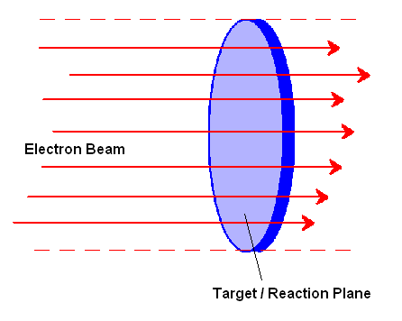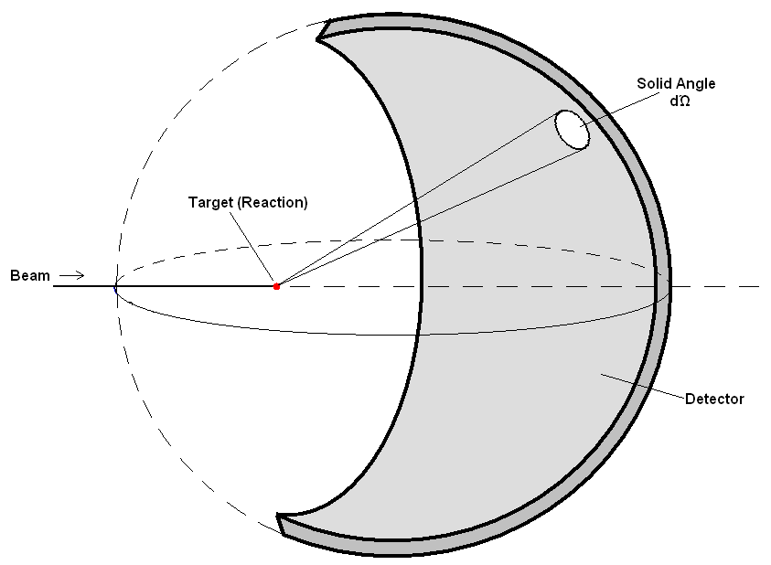
Figure 8: The ratio refers to the probability to observe a scattered particle. The numerator refers to the rate of scattered particles, divided by the solid angle which is show in the figure to the right. The denominator of the equation refers to the incident rate or the rate of the beam, multiplied by the amount of nuclei in a unit area. The first picture shows a definition of flux, as the electron beam passes through a target. The second shows the cross section of an election scattering from a target. It shows the detector and the solid angle of the reaction⁹.

The cross section is used to have a measurable quantity about the scattering reaction that is independent of devices used. The solid angle measurement is a property of the detector, the incident rate is a property of the bean and the targets/area is a property of the target used. These factors affect each other, and cancel out to give a quantity that represents the probability of a reaction and is device independent.

For the D(e,e’p)n reaction the differential cross section is given by:
$$\frac{d^{3}σ}{dωdΩ_{e}dΩ_{p}}=σ(θ,φ)=σ_{L}+σ_{T}+σ_{\text{LT}}\text{cos}(φ_{\text{pq}})+σ_{\text{TT}}\text{cos}(2φ_{\text{pq}})$$

Each term represents the cross-sectional area in either the longitudinal (L) or transverse (T) components and their cross terms. The longitudinal and transverse directions are both in the reaction plane of Figure 7. The longitudinal is the direction of $q$. The transverse direction is perpendicular to this. We are looking to measure σ_{TT}. We create an asymmetry A_{TT} which is less vulnerable to systematic uncertainties such as the acceptance of the detector.

$A_{\text{TT}}=\frac{σ_{\text{TT}}}{σ_{L}+σ_{T}}$We define the asymmetry as

To extract the A_{TT} from our data consider the following derivation. We begin with the cross section formula:
$$\frac{d^{3}σ}{dωdΩ_{e}dΩ_{p}}=σ(θ,φ)=σ_{L}+σ_{T}+σ_{\text{LT}}\text{cos}(φ_{\text{pq}})+σ_{\text{TT}}\text{cos}(2φ_{\text{pq}})$$

$\int_{0}^{2π}{\frac{d^{3}σ}{dωdΩ_{e}dΩ_{p}}\text{cos}{mφ}_{\text{pq}}{dφ}_{\text{pq}}=}\int_{0}^{2π}{(σ_{L}+σ_{T}+σ_{\text{LT}}\text{cos}(φ_{\text{pq}})+σ_{\text{TT}}\text{cos}(2φ_{\text{pq}})d}φ$Consider:

Because of the orthogonality of the following functions when n does not equal m:
$\int_{0}^{2π}{\text{sin}nφ\text{cos}mφ}dφ=0$$\int_{0}^{2π}{\text{cos}nφ\text{cos}mφ}dφ=0$
and

$\begin{aligned}\int_{0}^{2π}{\frac{d^{3}σ}{dωdΩ_{e}dΩ_{p}}\text{cos}2φ_{\text{pq}}{dφ}_{\text{pq}}=}σ_{\text{TT}}π \\ \end{aligned}$When m = 2:

And when m =0
$\begin{aligned}\int_{0}^{2π}{\frac{d^{3}σ}{dωdΩ_{e}dΩ_{p}}}{dφ}_{\text{pq}}=2π(σ_{L}+σ_{T}) \\ \end{aligned}$

We combine these equations to obtain:
$2\frac{\int_{0}^{2π}{\frac{dσ}{dΩ}}\text{cos}2φdφ}{\int_{0}^{2π}{\frac{dσ}{dΩ}}}=\frac{σ_{\text{TT}}}{σ_{L}+σ_{T}}=A_{\text{TT}}$

In our analysis we bin the data in Q² and p_{m}, the missing momentum for a particular bin A_{TT} is then :

$$A_{\text{TT}}=\frac{\sum{\text{cos}2ϕ_{i}}}{N}$$

where the sum is over all events in the bin and N is the total number of events in the bin.
We use a ratio because otherwise we would have to account for the acceptance and efficiency of the detector. By using a ratio, these constants cancel out, leaving us with a more precise quantity.

Below is the asymmetry found in the data at an electron beam energy E = 4.2 GeV and for quasi-elastic scattering where the electron scatters from either the proton of the neutron inside the deuteron without losing any kinetic energy:

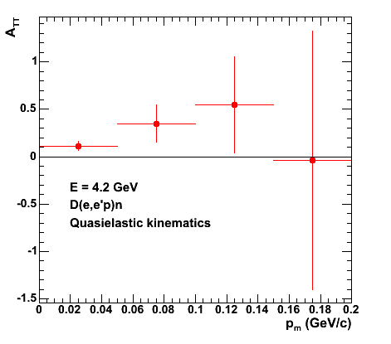
Figure 9: Asymmetry found in the real data.

CLAS Simulations

CLAS is a complex detector, and we use simulations to understand its response and to separate the real physics effects from the artifacts of the CLAS response. We used a software package from CERN called GSIM to simulate the events. These simulated events were compared to actual data and then used to investigate false asymmetries that distort our physics results. GSIM uses a Monte Carlo simulation process. Because of the large number of random events needed to get precise calculations, the simulations are very computationally intensive¹⁰.

CLAS is a very large machine separated into six sectors. It is not perfectly aligned, and because of this we measure small vertex shifts in the y direction after reconstructing the particles trajectory. We want to mimic these shifts in our simulations. For each sector we measure the vertex shifts in the y direction in the data. Figure 10 is a graph displaying the measured vertex shifts in the six sectors. It is important to notice that these are the shifts seen in the real data. It is worth noting here that we are taking advantage of the large solid-angle coverage of CLAS by measuring the out-of-plane dependence¹⁰.

The vertex is the point where the electron hit the deuteron. It should be perfectly aligned so that the detector can reconstruct the event. We know from the data however, that there are small vertex shifts in the y direction which are caused by misaligned CLAS components. To investigate false asymmetries, data is simulated without true asymmetries. We use the vertex shifts in the real data shown in Figure 10, insert these shifts into the simulations and extract A_{TT} from the simulations.

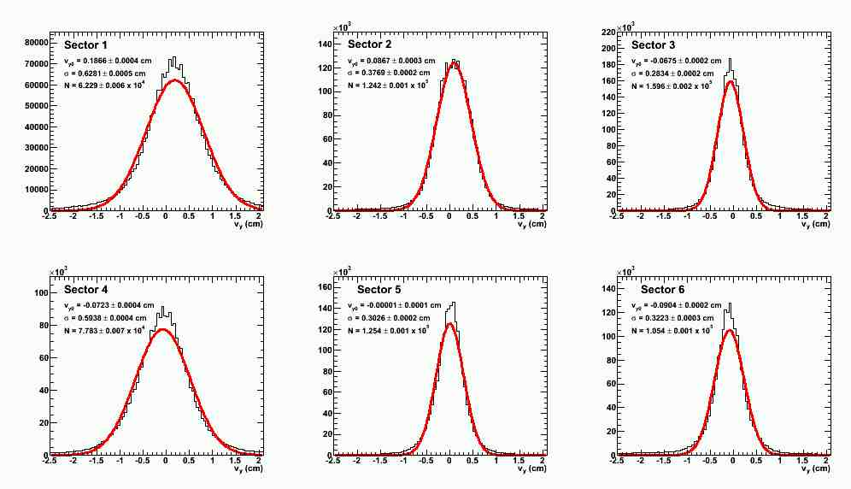
Figure 10: Vertex peaks with Gaussian fits from the real data

The calculations were performed on the University of Richmond physics supercomputing cluster. The procedure for running GSIM on the Spiderwulf is described here.

The first step is to submit a Perl script submit_sim.pl that is used to initiate the job and keep track of which of the nodes on the computing cluster are working. It initiates another Perl script run_queeqsim_on_node.pl which runs the following programs and manages the files. The important parts of the simulation process are below¹⁰:

1. The Quasi-Elastic Electron Generator (QUEEG) generates electron events by creating 4-vectors. These are the events stored in the PART bank. The events in the PART bank are not run through GSIM but are the inputs into the simulation.

2. GSIM simulates the CLAS response to the vectors created in QUEEQ, the results of which are stored in the EVNT bank. The EVNT bank has the same events stored as the PART bank, but after the events have been through the GSIM program. Because of this we have the inputs and outputs of GSIM.

3. Gppjlab removes the dead CLAS components (drift chamber wires, TOF scintillators etc).

4. RECSIS reconstructs the events from the event data and produces the 4-momentum and identity of each particle. This is the same program used to reconstruct tracks when analyzing the real data.

5. The code eod5root is used to create final histograms, process the 4-momentum vectors and is where we create the graphs of the asymmetries.

The shifts were determined by fitting a Gaussian curve to the data for each sector and then using the centroid of that curve as the vertex shift. The shifts were then inserted after the GSIM simulation and Figure 11 shows picture of the shifts from the simulation fitted with Gaussian curves. Notice how similar the simulated curves (Figure 11) are to the curves from the real data (Figure 10). Figure 12 shows the comparisons of the centroids.

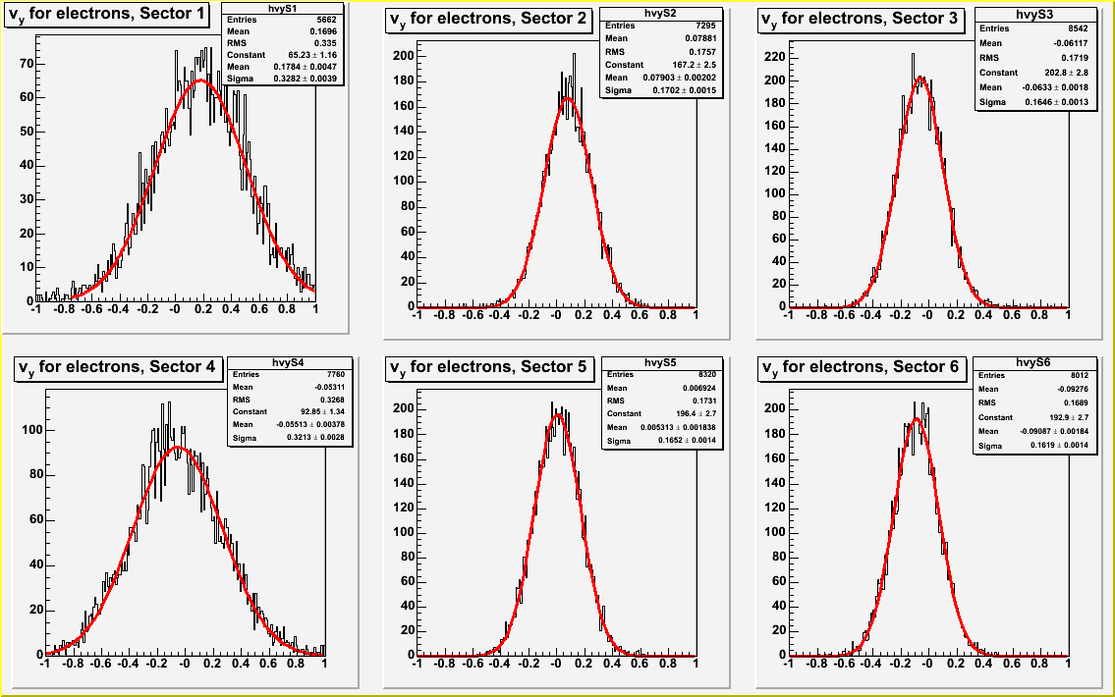
Figure 11: Peaks created from the simulation after the vertex shifts were inserted

Comparison of Centroids between the Data and Simulation
 | Data | Simulation
Sector 1 | 0.19 | 0.17
Sector 2 | 0.087 | 0.079
Sector 3 | -0.068 | -0.061
Sector 4 | -0.072 | -0.053
Sector 5 | -0.00001 | 0.0069
Sector 6 | -0.090 | -0.093
Figure 12: Comparison of centroids between simulated and actual data.

This simulation is then used with the vertex shifts to determine if there is a false asymmetry. When we shift the data in the simulations, we get a measurable asymmetry as shown below:

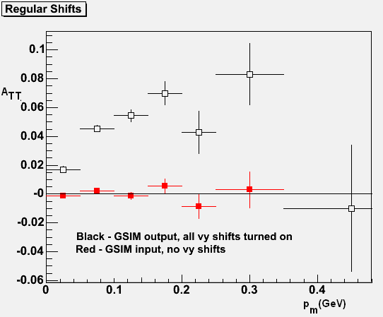
Figure 13: Asymmetry measured from the first shift.

The uncertainties of the asymmetry are statistical ones from the Monte Carlo simulation. Since the statistical uncertainties are very large at large p_{m}, from this point we will focus on the first three data points. The next step is to see how sensitive the calculated asymmetry is to the changes in v_{y}.

We used a shift of .01 cm which is roughly 1.5 times the accepted uncertainties for these peaks⁸. We shifted each vertex .01 cm above the mean vertex shift, and ran the simulation to find the asymmetry. I repeated this procedure on each of the vertex shifts for .01 cm below the mean as well. The resulting asymmetries are shown in Figure 14:

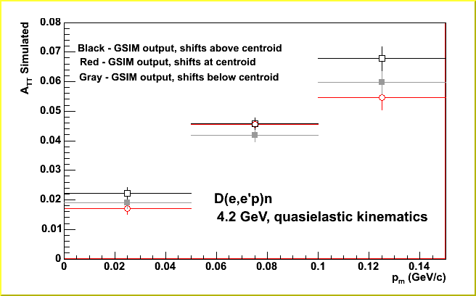

Figure 14: Asymmetries measured from the vertex shifts, the vertex shifts shifted above, and the vertex shifts shifted below.

As this graph displays, the asymmetry is statistically significant, non-zero, and does not change when v_{y} modified. Because of this, we can determine that there is a false asymmetry and assign an uncertainty to it. The weighted average in each p_{m} bin was calculated. The formula for the weighted average is as follows:
$x=\frac{\sum_{\text{data}}{\frac{x_{i}}{σ_{i}}}}{\sum_{\text{data}}{\frac{1}{σ_{i^{2}}}}}$ and the uncertainty is $Δx=\sqrt{\frac{1}{\sum_{\text{data}}{\frac{1}{σ_{i^{2}}}}}}$

The false asymmetry weighted average is shown in Figure 15.

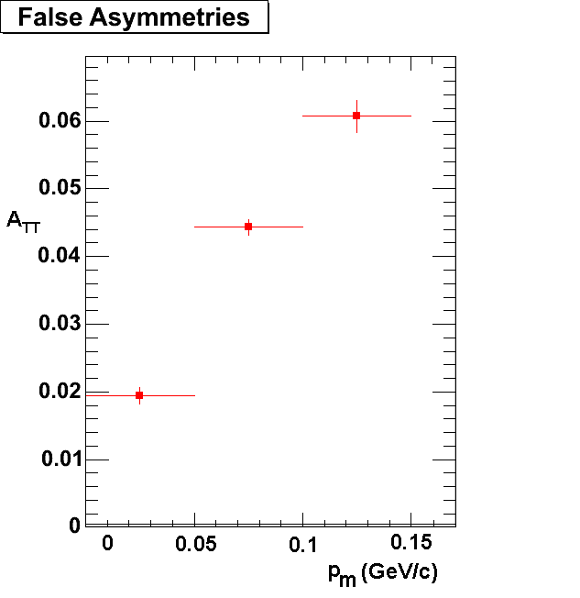
Figure 15: The averaged false asymmetries.

Since the asymmetry is significant, we should subtract this from the original data. This gives us the graph in Figure 16

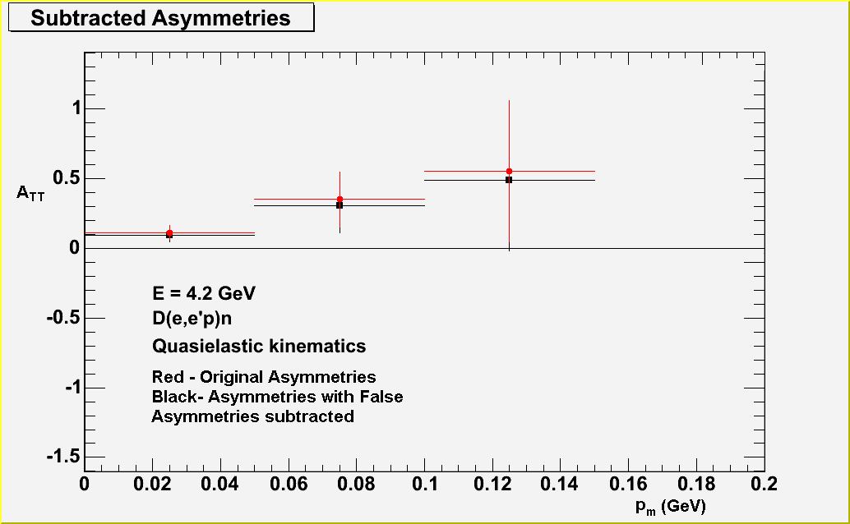
Figure 15: The real asymmetries (the data asymmetries minus the false asymmetries)

This final graph is the data with the true asymmetries.

One limitation of this data is that the vertex shifts were put in after the GSIM simulation. To further support these results, we will insert vertex shifts into the simulations before GSIM in run. We should also run longer simulations to reduce the uncertainties at high missing momentum. Finally, the experiment should be run at other beam energies in this data set to see if the results are consistent.

Conclusion

The overall goal of our research was to measure and determine the asymmetries for the σ_{TT} component of the D(e, e’p)n reaction. The σ_{TT} component is the fourth term in the cross section for the reaction and represents the transverse-transverse interference. The cross section is important because it is the theoretical representation of the physical reaction; we understand the reaction by determining the components of the cross section formula. However we run into the problem that σ_{TT} is subject to uncertainties such as the acceptance of the detector. To cancel out these uncertainties we use a ratio to create a more precise result. This ratio is A_{TT} or the TT asymmetry. The asymmetry A_{TT} has been measured but it is vulnerable to distortions due to misalignments of CLAS. To account for these effects we calculate the response of CLAS. We simulate data without asymmetries and the asymmetry is extracted after the simulation. For this experiment we inserted the vertex shifts from the real data to determine the effect that quantity had on the asymmetry. The vertex shifts from the real data were obtained by taking the mean of a Gaussian fit of the data. After inserting these shifts into the simulations, we observed an asymmetry beyond the uncertainty of zero in the first three data points (after that the data uncertainties were too large to draw conclusions). The inserted shifts were then shifted 1.5 times the accepted uncertainties for the mean of the vertex shifts. The results showed that for the first few points, the asymmetry was non-zero and not very sensitive to changes in v_{y}. We conclude there is a false asymmetry but it can be precisely calculated. This false asymmetry should then be subtracted from the real data to determine the real asymmetry.

Works Cited

¹ M. Barnett, A Erzberger, et al. The Particle Adventure; the fundamentals of matter and force, WWW Document, (http://paticleadventure.org) 01/09/2008.

² Contemporary Physics Education Project, Nuclear Science Poster, WWW Document, (http://cpepweb.org/) 01/09/2008.

³ The Nobel Foundation, The Nobel Prize in Physics 2004, WWW Document (http://nobelprize.org/nobel_prizes/physics/laureates/2004/) 01/09/2008.

⁴ Columbia Enclyclopedia, Quantum Chromodynamics, WWW Document, (http://www.encyclopedia.com/doc/1E1-quantumch.html) 01/09/2008.

⁵ T.P. Smith, Hidden Worlds (Princeton University Press, 2003).

⁶ Opportunities in Nuclear Science, The DOE/NSF Nuclear Science Advisory Committee, April 2002.

⁷ Thomas Jefferson National Accelerator Facility, Jefferson Lab; Exploring the Nature of Matter, (http://www.jlab.org) 01/09/2008.

⁸ B. Mecking, et al., The CEBAF Large Acceptance Spectrometer, Nucl, Inst. And Math. A, 524 (2004) 306.

⁹ V. Barger, M. Olssen, Classical Mechanics: A Modern Perspective (McGraw-Hill Inc, 1995).

¹⁰ R. Burrell, K. Gill, G.P. Gilfoyle, `CLAS Simulations for D(e,e’p)n, University of Richmond, Bull. Am. Phys. Soc., Fall DNP Meeting, BAPS 3A.00012 (2006).

