Extracting the Fifth Structure Function and Hadronic Fiducial Cuts for the CLAS E5 Data Run at Jefferson Laboratory
Senior Seminar Physics Paper
K. Greenholt (G.P. Gilfoyle)

16 April 2007

ABSTRACT

We have developed event selection cuts for positively charged hadrons from the D(e, e’p)n reaction in the CEBAF Large Acceptance Spectrometer (CLAS) at the Thomas Jefferson National Accelerator Facility. CLAS measures the scattering of electron and photon beams on nuclear targets and is a large, complex, particle detector. For accurate measurements we select data from regions of CLAS where its response is well understood. We use fiducial cuts to define the regions of CLAS where the azimuthal dependence of positive hadrons is constant. First, a trapezoidal function is fitted to this azimuthal dependence in a particular scattering angle and momentum bin of a proton or positive pion. Next, the limits of the trapezoid’s plateau are fitted as a function of the hadron scattering angle for each momentum bin. Last, the parameters of this second generation fit are fitted as functions of hadron momentum to give us well-behaved functions defining the active region of CLAS. We will discuss the details of this method and apply it to the electro-disintegration of the deuteron in the D (e, e’p) n reaction. The data were collected at beam energy of 2.6 GeV. Different magnetic field polarities were used for the 2.6-GeV data to cover a broader Q² range. We also present a method for extracting the fifth structure function that reduces the import of false asymmetries in CLAS.

1This work is supported by the US Department of Energy (contract DE-FG02-96ER40980).

INTRODUCTION

Matter is made up of fundamental building blocks and over the past century, we have achieved increasing depth in our understanding of these building blocks. During the early 20th century, we believed the smallest divisions of matter were the electrons, neutrons and protons. Now, nearly a decade into the 21st century, we know matter is made up of a combination of quarks, leptons, and force carriers. These constituent parts can be broadly categorized as fermions (matter constituents) and bosons (force carriers). Figures 1 and 2 show these fundamental components of matter by name, spin, mass, and charge:

Figure 1: Force Carriers
Figure 2: Matter Constituents

The Thomas Jefferson National Accelerator Facility (JLab) is a Department of Energy National Laboratory and is designed to study the fundamental properties of atomic nuclei in terms of quarks and gluons. It is comprised of a large electron accelerator (the Continuous Electron Beam Accelerator Facility or CEBAF) and three experimental research halls (Halls A, B, and C). The current experiments at JLab are dedicated to pursuing the study of three major research topics: the quark-gluon structure of the nucleus, the structure of the nucleon, and tests of the Standard Model.

I worked with Dr. Gerard P. Gilfoyle, of the Department of Physics at the University of Richmond, in the summers of 2004 and 2005, developing fiducial cuts for positively charged hadrons from the D(e, e’p)n reaction in the CEBAF Large Acceptance Spectrometer (CLAS) in Hall B at JLab. This paper describes the background for this research, gives an overview of the operations at JLab, describes how we extract the fifth structure function, describes how I determined the hadronic fiducial cuts used to select “good” events, and draws conclusions.

SCIENTIFIC BACKGROUND AND MOTIVATION

We are interested in understanding the forces that are at play within the nucleus; specifically, what forces hold quarks together. There are two standard models which can be applied: the Hadronic Model and the Standard Model using the theory of Quantum Chromodynamics (QCD).

The Hadronic Model works at low energies in which the nuclei can be approximated as collections of protons and neutrons. The Hadronic Model uses a phenomenological force fitted to data at low energy. This ‘strong’ force is the residual force between quarks [1]. The success of the Hadronic Model is demonstrated in the right-hand panel of Figure 3. The plot shows the ‘intensity pattern’ from a scattering experiment at JLab. The quantity on the vertical axis is the cross section, which can be viewed as the effective size of the target (deuterium in this case). The data are plotted versus Q² or the square of the 4-momentum transfer. Note the excellent agreement between the data points and the hadronic model calculation by Van Orden, et al. [2] covering five orders of magnitude.

We also have a working theory of strong interactions between quarks: quantum chromodynamics or QCD [3]. The Quantum Chromodynamics Model (QCD) predicts a property known as asymptotic freedom (D. Politzer, F. Wilczek, D. Gross: 2004 Nobel Prize in Physics) which means that at very high energies, quarks and gluons interact very weakly [4]. This feature of the force has enabled us to understand QCD very well at very high energies. QCD also predicts confinement, meaning that the force between quarks does not decrease as they are separated, but rather, it stays the same. For high energy interactions, QCD is very successful. The left panel of Figure 3 shows the cross section for interactions as a function of E_{T}, the transverse energy flow [5a,b]. The calculated curves are from QCD, and go through the data points over a range of six orders of magnitude.
Figure 3: Four-Momentum vs. Effective Target Area: QCD (left); Hadronic Model (right)

We do not, however, have a transition model which effectively bridges the gap between the Hadronic model and QCD. In other words, we can’t get QCD and the hadronic model to line up [6]. This is demonstrated in Figure 4. Figure 4 shows a measurement of the polarization observable t₂₀ at low energies which is sensitive to different components of the cross section. The data are reproduced by Hadronic Model calculations (the dashed curves), but not by a QCD calculation (the solid, straight line).

Figure 4: Predictions for QCD at medium range energies; the blue line indicates the QCD prediction for low Q²

Jefferson Laboratory (JLab) plays a vital role in developing our understanding of the transition from nucleonic degrees of freedom (protons and neutrons) to quark-gluon ones. It deals with the critical mid-range energies, working on connecting the QCD and the Standard Model with the Hadronic model, so that we can more clearly see the transition from the nuclear picture to the quark picture of QCD.

EXPERIMENTAL BACKGROUND

CEBAF

The Continuous Electron Beam Accelerating Facility (CEBAF) at JLab in Newport News, Virginia, is used to study the properties of quark matter. CEBAF is an electron accelerator which is about 7/8 of a mile around, and 25 feet underground. It is capable of producing electron beams with energies of 2-6 GeV. The electron beam is accelerated through the straight sections and magnets are used to make the beam travel around the bends. An electron beam can travel around the accelerator up to five times near the speed of light. The beam is then sent to one of three halls where the beam collides with a target and the debris is measured. The target in our particular experiment is deuterium, a stable isotope of hydrogen consisting of a proton and a neutron.

CLAS

CLAS is the CEBAF Large Acceptance Spectrometer, and is located in Hall B. It is used to detect electrons, protons, pions, photons, neutrons, and other subatomic particles. CLAS is a 45-ton, $50-million radiation detector. The detector is able to detect most of the particles created in a nuclear reaction, because of its unique nearly-full-solid-angle structure. Figure 5 shows this unique structure. The detector is divided into six azimuthal sectors, each covering approximately 30 degrees. Sector 1 runs from -30º to 30º; sector 2 from 30º to 90º, and so on.

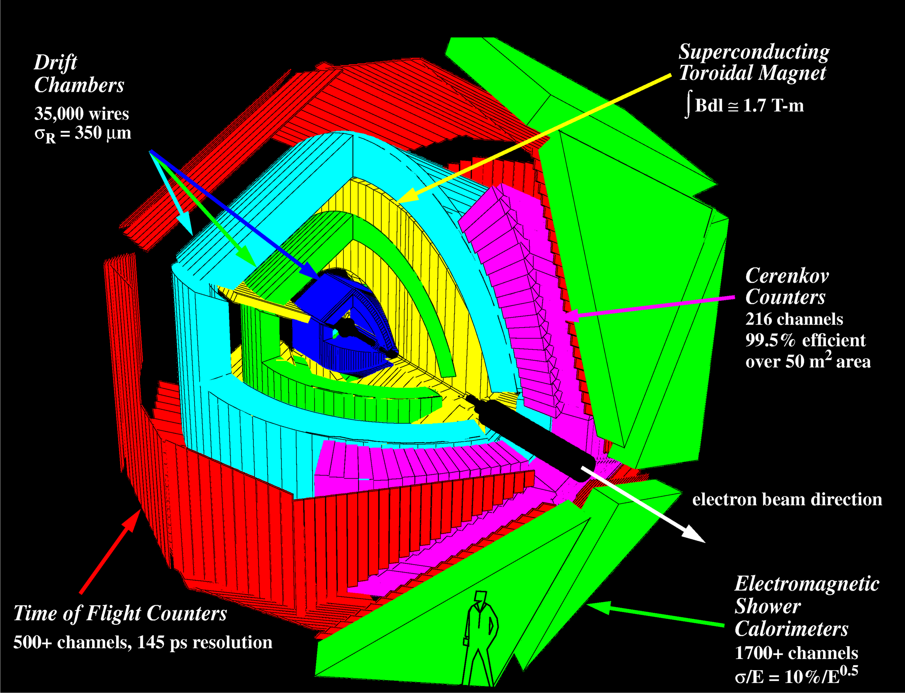
Figure 5: CLAS

CLAS contains nearly 40,000 detecting elements in about 40 layers. There are six major regions of CLAS (see Fig. 6) which produce electrical signals, providing us with information on velocity, momentum, and energy, and allow us to identify different subatomic particles. The first three regions contain the CLAS Drift chambers that map the trajectory of the collision. A torodial magnetic field is used to bend the trajectory in the middle region of the drift chambers to measure the momentum. Other layers measure energy (calorimeters), time-of-flight (scintillators), and permit particle identification (Cherenkov counters). Each collision is reconstructed and the intensity pattern reveals the forces and structures of the colliding particles. We describe these systems in more detail below.

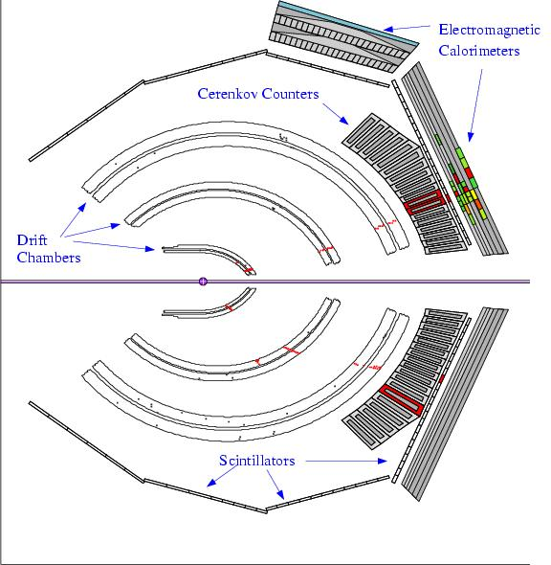
Figure 6: CLAS Event Display (CED) displays signals received from each layer of CLAS

The drift chambers make up the first three regions, containing 34 layers, and determine the paths of charged particles. The drift chambers at JLab contain about 32,000 sense wires, each with a diameter of 30 micrometers. The charged particle ionizes the atoms in the gas within the drift chambers and the displaced electrons drift towards the positively charged wires. The wires then relay an electronic signal back to the data acquisition system. The series of “hits” allows us to reconstruct the path of the particle.

The next layer is the Cherenkov counters which separate electrons from pions. Within the detector, the Cherenkov counters are separated into six sectors, each spanning approximately 8-45 degrees in polar angle θ. Cherenkov counters rely on a phenomenon known as Cherenkov light, which is named after Russian physicist Pavel Cherenkov. Cherenkov noted that when a particle moving at nearly the speed of light entered a medium which was optically thicker than air, with a slower speed of light, the particle was forced to observe the new “speed limit.” In order to slow down drastically, the particle releases energy, which is translated into an optical light burst, known as Cherenkov light. This is used to separate electrons from pions. The pion is much more massive than the electron and is moving less than the speed of light in the gas so it emits no Cherenkov light. The coincidence of a track in the drift chambers with a Cherenkov signal identifies the electron. The electron emits a much louder light boom upon entering the Cherenkov counter, enabling us to distinguish between particles.

The following layer is made of plastic scintillators to determine time of flight (ToF) and hence velocity when combined with the path length from the trajectory measured with the drift chambers. The scintillators are located 3 meters from the target, and contain 300 bars (2”x 6”) ranging in length from 0.5 - 4 meters long, made of scintillating plastic. When an ionized particle passes through one of these bars, the bar emits a burst of light. The device also contains photo-multiplier tubes (PMTs) which are located at each end of the scintillators. These are highly sensitive light detectors, which detect even a single photon. The combination of these two components allows us to determine the time at which the particle transverses the ToF scintillator to within 100 to 200 picoseconds.

The calorimeters, used to measure the energy of the particles, make up the final layer. These are composed of many alternating layers of lead and scintillating plastic; the lead causes the particles to release energy. As the moving particles collide with the particles in the lead, they create a shower of other particles. The shower of particles generates light as it passes through the plastic layers. The calorimeters are thick enough to stop all the particles reaching them so they can measure the full energy of each particle. This allows us to measure the energy associated with the track.

Also in CLAS is a toroidal magnet that causes charged particles to bend as they pass through the middle region of drift chambers. Magnets are wrapped azimuthally around the electron beam line to create a toroidal shaped field. Unscattered electrons pass through the “hole” along the beam line unscathed, and into a beam dump. High momentum particles are only slightly deflected, whereas low momentum particles are drastically deflected. This bending is used to determine momentum. The magnetic field is created by six, superconducting coils, and has two different polarity settings. Normal polarity creates in-bending (toward the beam line) electrons and out-bending (away from the beam line) positrons, whereas reversed polarity generates out-bending electrons and in-bending positrons. The properties of this magnetic field are of particular interest to us, as we attempt to define the fiducial volume of the detector, because it affects the regions of uniform efficiency.

When a particle triggers a signal in successive layers of the CLAS, we call this an “event.” These events are then grouped by corresponding sectors in momentum and θ bins. The characteristics which we can ascertain from CLAS such as the velocity, momentum, energy, and scattering angle allow us to identify the different subatomic particles which are present in the scattering reaction.

EXTRACTING THE FIFTH STRUCTURE FUNCTION

The physics goal of the project is to measure the so-called fifth structure function. The cross section (Eq. 1) is the meeting ground between theory and experimental and for the reaction can be written as:

(1)

where each term on the r.h.s. represents the effective cross-sectional area in longitudinal (L) or transverse (T) components and their cross-terms () and h is the helicity of the beam. The beam is polarized with the spin either aligned (h = +1) or anti-aligned (h = -1) with the momentum of the beam. The definition of φ_{pq} and the other kinematic quantities is shown in Figure 7 below. The last term in Eq. 1 contains the fifth structure function σ’_{LT}. It is unique for two reasons. First, it is non-zero only when φ_{pq} is non-zero for out-of-plane measurements. As a result, it has scarcely been measured in the past. Second, it is formed from the imaginary part of the longitudinal-transverse (LT) interference terms in the probability density. It opens a window into a poorly-known part of the deuteron wave function. As a result of the unique solid-angle coverage of CLAS, we are able to measure the fifth structure function, and test the Hadronic model. This analysis was performed on the E5 data set, covering a Q² range from 0.2 to 5 (GeV/c²).

Figure 7: Kinematic quantities for thereaction.

To extract the fifth structure function from our data, we form the asymmetry (Eq. 2) as a ratio of cross-section terms. The asymmetry is less vulnerable to systematic uncertainties because the corrections cancel out in the ratio. It allows us to isolate the term.

(2)

To isolate the σ’_{LT} from the measured cross-section, we apply the principle of Orthogonality. For sine and cosine functions we have the following results for integers n and m (Eq. 3).

all
(3)
Consider the following integral

(4)

By orthogonality and equation 3 the only term surviving the integral on the right-hand side is the term, so (Eq. 5):

(5)
Now consider

(6)

We can now form the weighted average:

(7)
These weighted averages can be combined to yield

(8)

In principle, we have two measurements for ; one for each beam helicity. However, it is possible that the azimuthal acceptance of CLAS may have a sinusoidally varying component due to misalignments, missing detector components, etc. Consider such an effect so that

and
(9)

where is the rate of events in CLAS for different helicities. Following the same steps as above (Eqs. 4-8) one can start with

(10)

and show that

(11)

In the denominators for both terms, we expect from past experience that and a >> b so that the term can be neglected. The result is

(12)

Where the first term is and the second term is non-zero only when and. This second term is a “false asymmetry” which can contaminate and distort our results. However, there is a simple ploy to eliminate. Consider

(13)

By taking the difference between the weighted averages for the different beam helicities we can cancel the false asymmetry. Similarly, we can also isolate the false asymmetry, for the purposes of study, by taking the sum of the weighted averages for the different beam helicities.

(14)
Figure 8 demonstrates the results which come out of these mathematics. The missing momentum, P_{m} is defined as

(15)
whereis the incoming beam momentum, is the scattered electron momentum, and is the ejected proton momentum. In the upper panels, we see the positive and negative helicity sine functions plotted against the missing momentum. According to equation 7, the two sine functions should be opposite of one another. The two upper panels in Figure 8 demonstrate that this is clearly not true. Our mathematical ploy removes the false asymmetry which causes this distortion. The lower panels show the corrected asymmetry (left) and the false asymmetry (right).

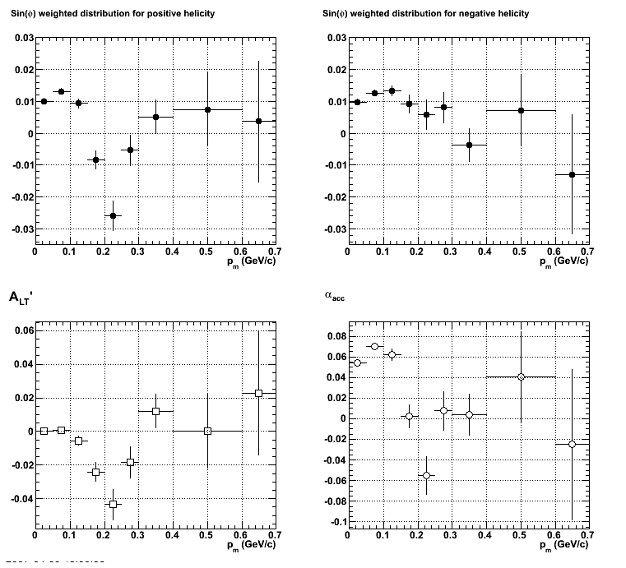
Figure 8: Clockwise from Top Left, <Sin φ>₊, <Sin φ>₋, and Sum (α_{acc}) and Difference (A’_{LT}), plotted against the missing momentum.

HADRONIC FIDUCIAL CUTS

EXPERIMENTAL CHALLENGE

In regions of CLAS near the current-carrying coils that produce the magnetic field, the efficiency, or acceptance, of the detector is not well known due to unknown alignments of the current coils inside their cryostats. To remove these events from our sample, we put constraints (fiducial cuts) on electron, proton, and pion scattering angles to exclude the regions of the magnetic field near the coils and only accept data where the acceptance is uniform. We have collected data for electrons on deuterium during the E5 running period at JLab with beam energies of 4.2 GeV and 2.6 GeV. The polarity of the toroidal magnet was set so electrons bend towards the beam. A third data set is at 2.6 GeV with the magnet polarity reversed. We have generated fiducial cuts for hadrons (protons and pions) from CLAS for the 2.56-GeV data with normal and reversed torus polarity. We built on the methods developed by R.Nyazov and L. Weinstein [7].

FIDUCIAL CUTS:

We start with protons and pions events in coincidence with electrons in CLAS (see Figure 9). We plot the number of events versus the φ angle in a θ angle bin for a particular hadron momentum bin (see Figure 10). We then use a CERN program called Minuit to fit a trapezoidal curve to the data points. The fiducial cut is defined as the edge of the central plateau of the solid curve in Fig. 10.

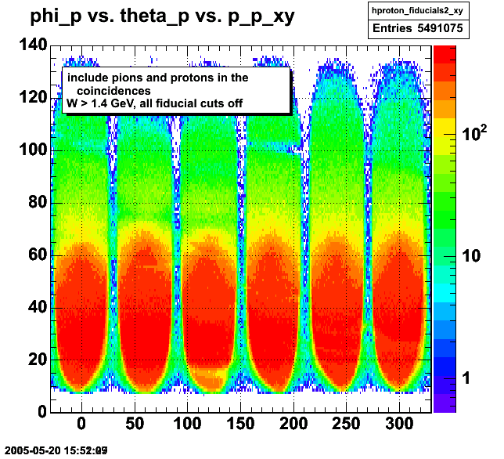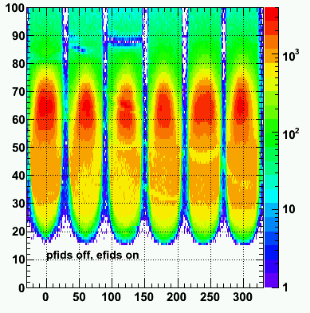
Figure 9: Data plot from CLAS showing θ versus φ for electron-hadron coincidences. Left is 2.56 GeV, normal polarity, Right is 2.56 GeV, reversed polarity.
Note: six sector configuration.

Notice in Figure 9 the proton-pion “peninsula”, around 65º in the left-hand panel, and around 76º in the right-hand panel. We will discuss this feature more later. Note also the number of events which appear between the sectors, indicating non-well-defined sector edges and plateaus. In order to perform the analysis, we take a horizontal cut through the data, plotting the number of events versus the angle φ for a particular θ angle bin (Figure 10).

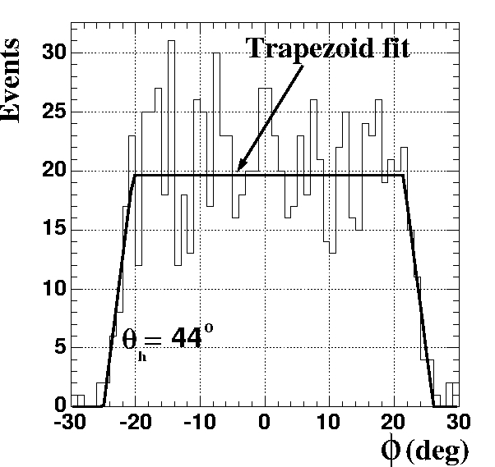
Figure 10: Fiducial cut in terms of events plotted against φ angle, showing the region of stable efficiency in the φ distribution for the hadrons in the labelled momentum and θ bin.

In performing these first generation fits, we refine the edges for the fiducial cuts, using three tools:

- Visual Fit: How well does the fiducial graph fit the actual data plot? In other words, are we cutting out good data, or including events that should be excluded? In some instances MINUIT would fail to find the correct lower φ  edge. We corrected for this by either manually resetting the starting point for this parameter in the fit or by simply running the fit again.
- Minimized χ²: The is defined as
where y_{i} is a data point, f(x_{i}) is a curve at the same abscissa as y_{i}, and σ_{I} is the uncertainty in y_{i}. If the observed was not consistent with nearby points, we would redo the fit to exclude the point.
- Reasonable Error: We observed uncertainties (σ²) on some fit parameters that were orders of magnitude smaller than expected (~10⁻³). This would cause the point to be weighted more, distorting the second generation fits that are discussed below. We corrected for this problem again by manually resetting the starting point for the fit edge, or by running the fit again. The majority of errors could be corrected by merely running the fit again.

We now describe one of the challenges we faced with this data set. To find the edge of the acceptance, the azimuthal or φ dependence must be uniform. In Figure 9, this is not true for events in the peninsula. These events are protons and positive pions in coincidence with electrons usually in the opposite sector in CLAS. The ‘peninsula’ here is a reflection of the forward-angle electron acceptance of CLAS (these are electron-hadron coincidences). To test this idea we exclude electrons with θ_{e}<40 degrees in sector 4. The effect on the hadron acceptance is shown in Figure 11. The hadron ‘peninsula’ has disappeared in sector 1, opposite sector 4 with the electron. This cut reduces our statistics, but our sample is more uniformly distributed in φ. We also include cuts on W, the recoiling mass to exclude quasi-elastic events. The final hadron sample for the 2.6-GeV, normal and reversed torus polarity data are shown in Figure 12.

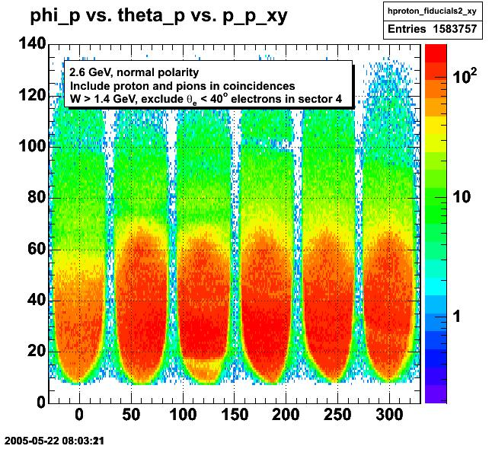
Figure 11: Effect of forward-angle electron cut in sector 3.

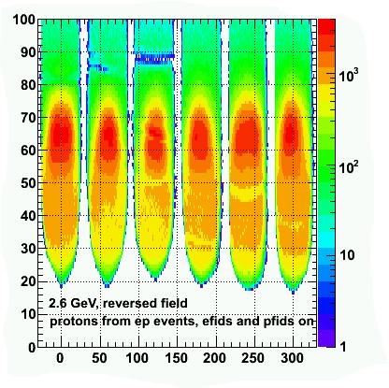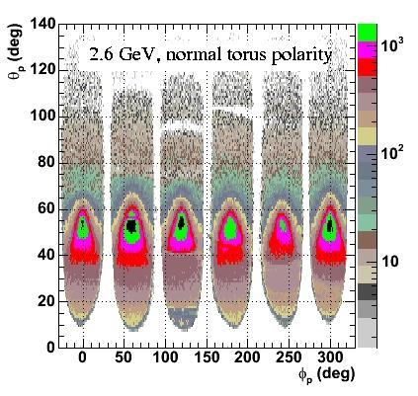
Figure 12: L to R, Effect of hadron fiducial cuts on hadron acceptance for e-p events, 2.6 GeV, reversed polarity data; 2.6 GeV, normal polarity data.

Once the first generation fits are complete, we then fit the upper and lower sector edges defined by the first generation trapezoidal fits, and plot them against the θ the polar hadron angle. We use Minuit to fit another curve to these data points (See Figure 13).
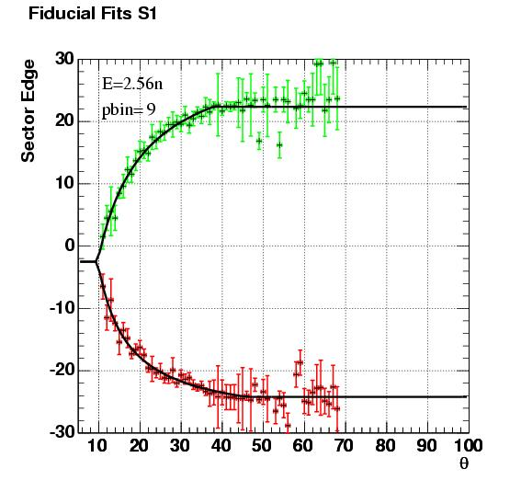
Figure 13: Sector 1, 2.56 Normal Torus Polarity data, momentum bin 9.

The function used in the fit is the following:
$φ_{\text{edge}}=φ_{\text{mid}}±b\left(1−\frac{1}{1+{\left(θ_{h}−t_{0}\right)}/a}\right)$

(15)

where φ_{edge} is the azimuthal angle of the edge of the uniform acceptance (Eq. 15) for a given hadronic scattering angle θ and momentum bin and a, b, t₀, and φ_{mid} are parameters. The plus or minus is for the upper or lower edge of the acceptance. The value of φ_{mid} is fixed at the value of the mid-point of the first good θ bin. Some results for one sector and one hadron momentum bin are shown in Figure 13. In the first iteration of the fit the values for a, b, and t₀, are varied for each side of the sector. In the second iteration the value of t₀ is restricted to a narrow range defined by the first iteration results. We also include a cut-off where the θ dependence becomes constant that we take from the data. We call these second generation fits.

The final step is to plot the results generated by the second generation fits against the momentum of the hadron (measured when the particle passes through the toroidal magnet), and fit these data with a polynomial function. We want to generate fiducial cuts that vary smoothly with hadron momentum, scattering angle θ , and azimuthal angle φ. Some sample results for sector 1 are shown in Figure 14. The full set of third generation fits can be seen in the Appendix.

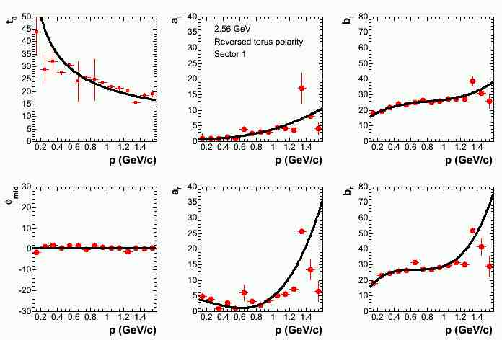
Figure 14: Sector 1, 2.56 reversed torus polarity.

This analysis is similar to the procedure we also applied to the electron fiducial cuts. The hadronic cuts required about 20,000 first generation fits, 1,400 second generation fits, and 250 third generation fits. These parameters allow us to reconstruct the proton-pion acceptance. Figure 12 shows the final results of the fiducial cuts for all running conditions of the E5 data run. In Figure 12, we see that the data have been reduced, but the peninsula which we saw in Figure 9 has flattened out. The individual sectors become better defined and more distinct, and the events which fall near the edge of the sectors, and are most vulnerable to changes in the magnetic field have been excluded.

CONCLUSIONS

We have demonstrated a method of extracting the fifth structure function for the D(e,e’p)n reaction and eliminating false asymmetries. We have also developed hadron fiducial cuts for the E5, 2.6 GeV data, CLAS data. These cuts enable us to select events from regions in CLAS where the magnetic field is uniform. Further, we are able to isolate regions of stable efficiency and remove contaminated data points (see Figure 14).

SOURCES:

[1] L.C.Alexa, et al., Phys. Rev. Lett., 82, 1374 (1999).
[2] Van Orden, et al. Phys. Rev. Lett. 75, 4369 - 4372 (1995)
[3] B.Abbott, et al., Phys. Rev. Lett.,86, 1707 (2001).
[4] http://en.wikipedia.org/wiki/Quantum_chromodynamics
[5a] B.Abbott, et al., Phys. Rev. Lett.,86, 1707 (2001)
[5b] L.C.Alexa, et al., Phys. Rev. Lett.,82, 1374 (1999)
[6] D. Abbott, et al., Phys. Rev Lett. 84, 5053 (2000).
[7] R. Nyazov and L.Weinstein, CLAS-Note 2001-013

Appendix A: Third Generation Fits.

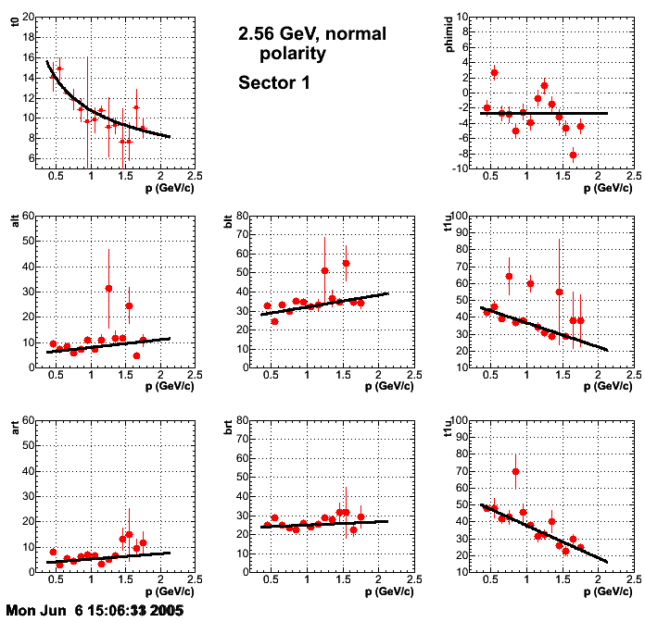
Figure A.1 2.6-GeV, normal torus polarity, sector 1.
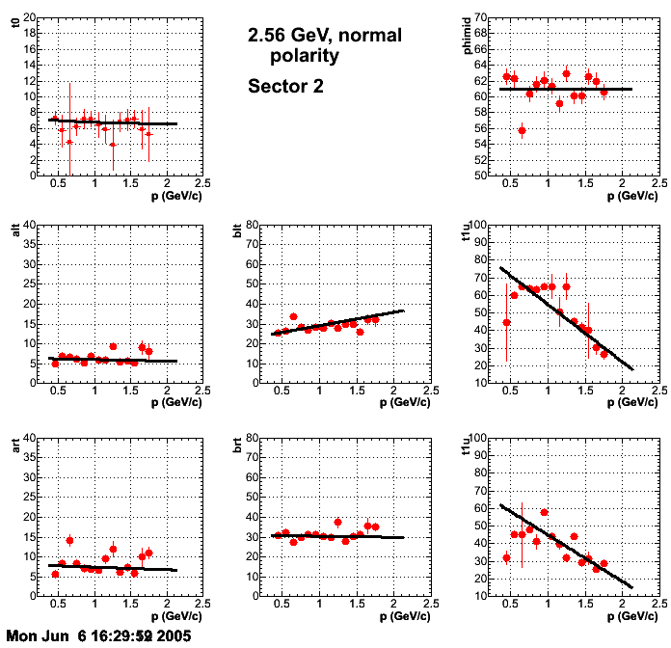
Figure A.2 2.6-GeV, normal torus polarity, sector 2.
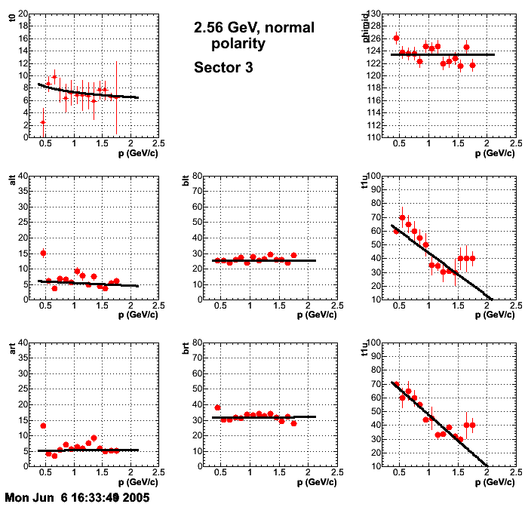
Figure A.3 2.6-GeV, normal torus polarity, sector 3.
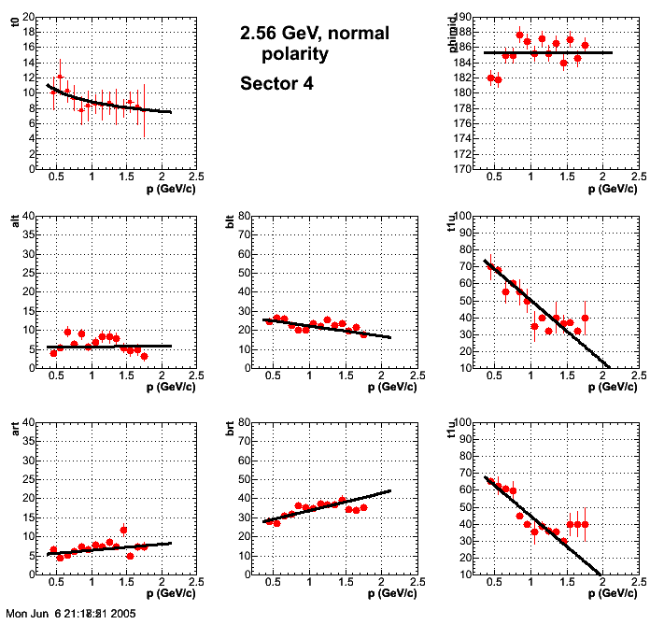
Figure A.4 2.6-GeV, normal torus polarity, sector 4.
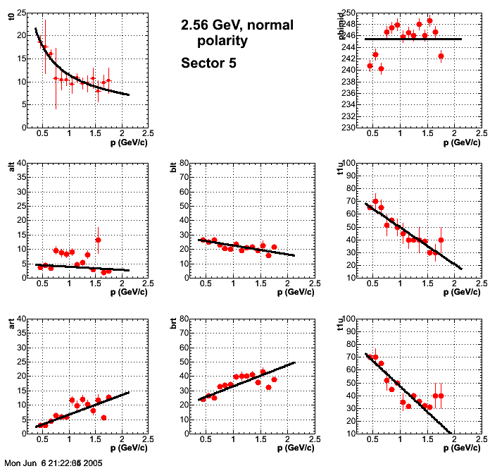
Figure A.5 2.6-GeV, normal torus polarity, sector 5.
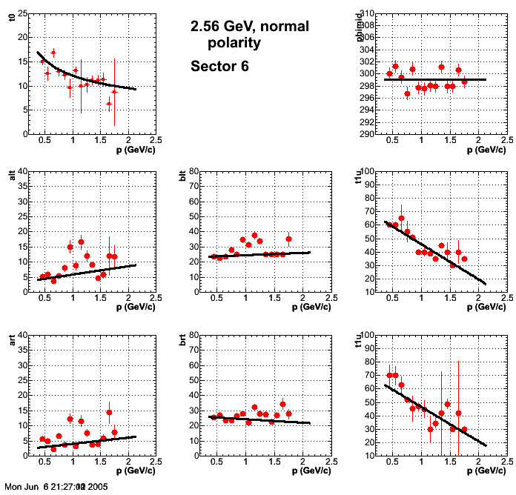
Figure A.6 2.6-GeV, normal torus polarity, sector 6.
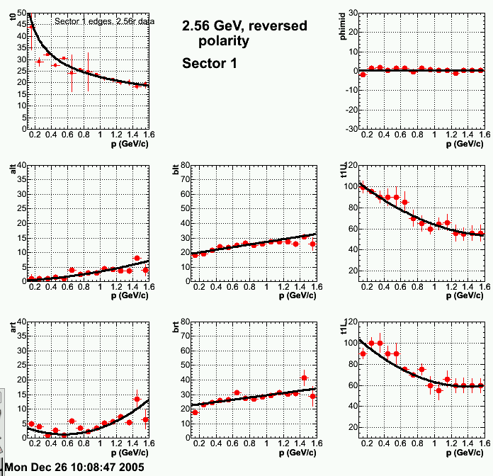
Figure A.7 2.6-GeV, reversed torus polarity, sector 1.
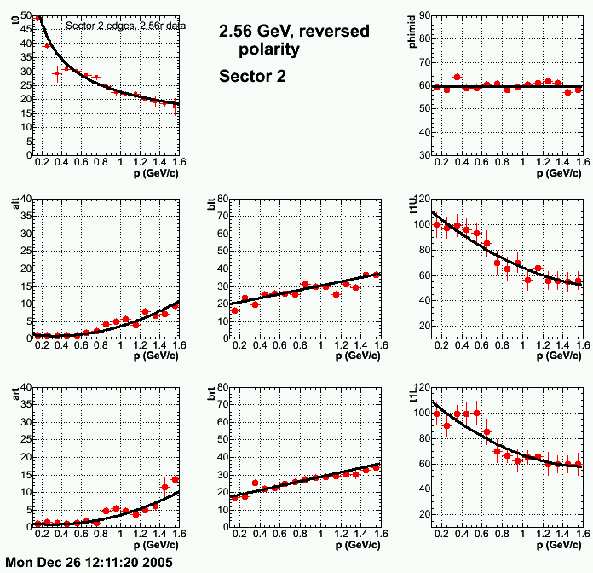
Figure A.8 2.6-GeV, reversed torus polarity, sector 2.
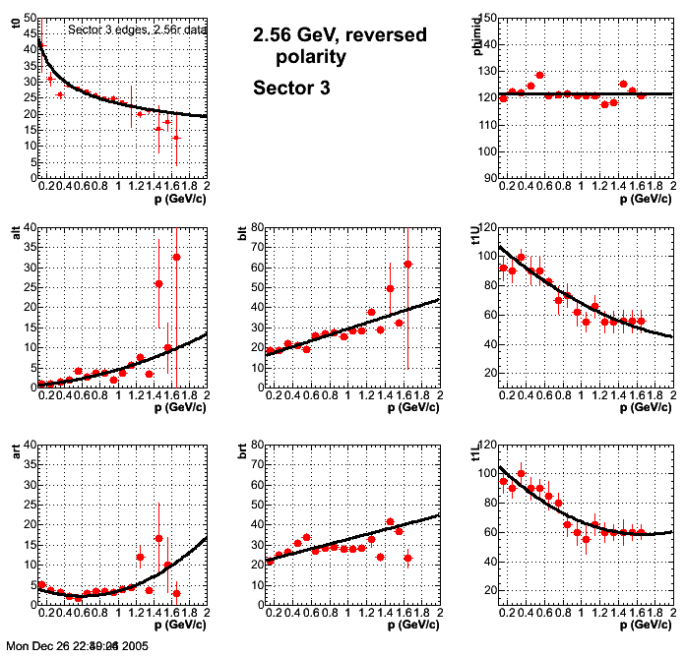
Figure A.9 2.6-GeV, reversed torus polarity, sector 3.
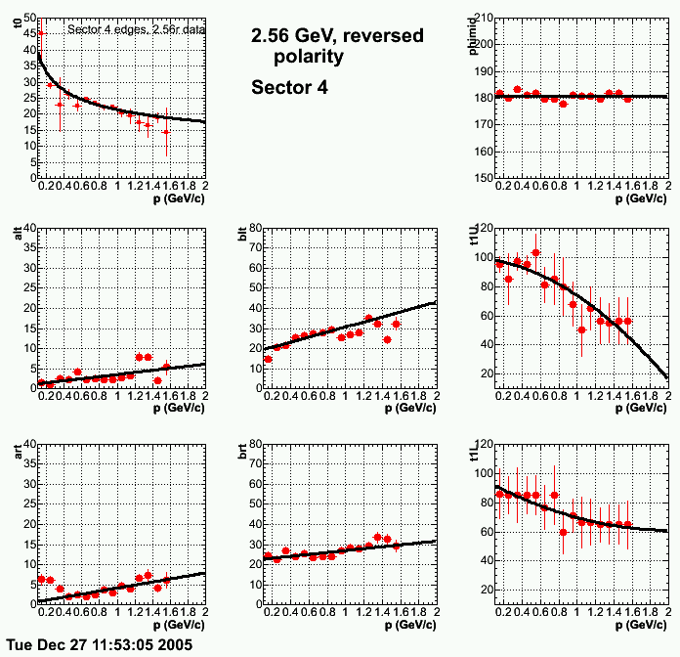
Figure A.10 2.6-GeV, reversed torus polarity, sector 4.
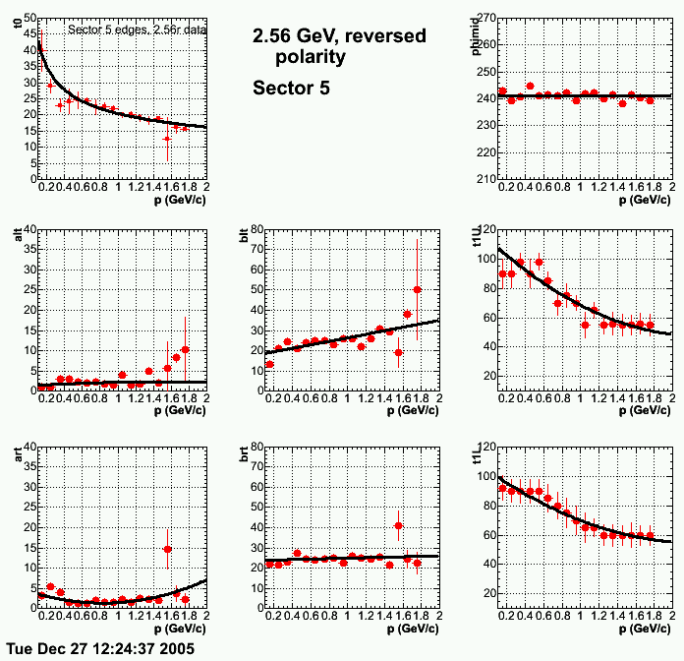
Figure A.11 2.6-GeV, reversed torus polarity, sector 5.
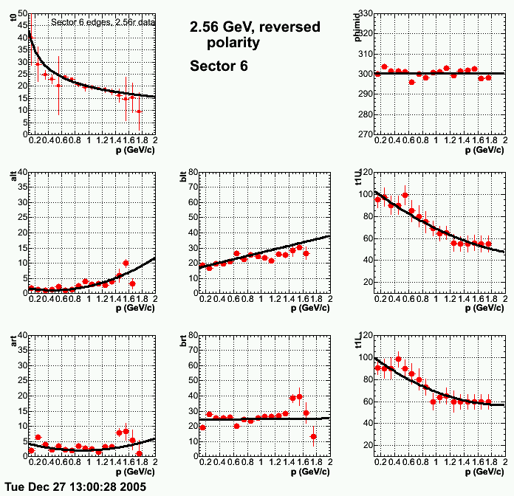
Figure A.12 2.6-GeV, reverrsed torus polarity, sector 6.

