Magnetic Structure of the Ground State Neutron

The electromagnetic structure of the proton ground state has been mapped out for over 50 years and with high precision and in a large range of Q². However, only recently has it become possible to access the magnetic structure of the neutron with similarly high precision. A recently published result [1] by the CLAS collaboration measured the magnetic form factor of the neutron using the ratio method on deuterium. The precision and coverage of these results eclipse the world’s data on this elastic form factor in the Q² range of 1.0 – 4.8 GeV². The experiment used a double-cell target made from liquid hydrogen and liquid deuterium and detected the quasi-elastic reactions en(p_{s})→en and ep(n_{s})→ep from the deuterium cell and ep→eπ⁺n from the hydrogen target. The first two quasi-elastic reactions measure the cross section ratio of the neutron and proton simultaneously, which allows the control of systematic uncertainties at the 2-3% level. The π⁺n reaction on hydrogen allows a precise calibration of the neutron detection efficiency in situ and measures the calibration reaction simultaneously to the physics reaction, in real time. The left panel in the figure shows the neutron detection efficiencies for the electromagnetic calorimeters and the time-of-flight plastic scintillators. The neutron magnetic form factor is shown in the right panel. Surprisingly, it deviates from the dipole form by not more than 10% in the entire Q² range covered (see theoretical curves in the figure below). The CLAS results are consistent with the previous world's data, but have much smaller uncertainties and better coverage. An experiment to push this measurement to nearly three times the upper Q² limit of the current CLAS data has been approved for running in Hall B with the new CLAS12 detector after the 12-GeV Upgrade is completed.
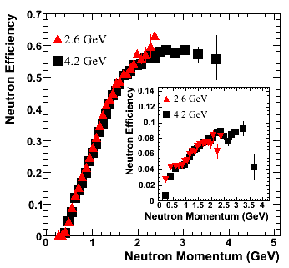
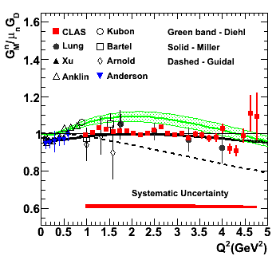

Figure: The left panel shows the results of the neutron detection efficiency for the CLAS electromagnetic calorimeters and the TOF system (inset). The right panel shows the magnetic form factor of the neutron normalized to the dipole form factor with results from other measurements and theoretical curves. The red symbols represent the new CLAS results.
[1] J. Lachniet et al. (CLAS collaboration), arXiv:0811.1716 [nucl-ex].

